\SWANSEA WOMEN’S AID
APPLICATION PACK

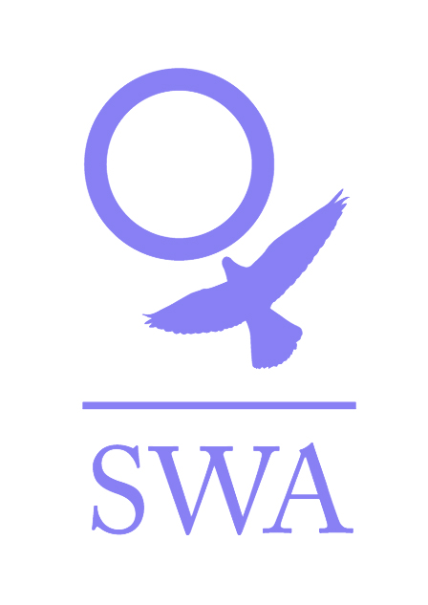

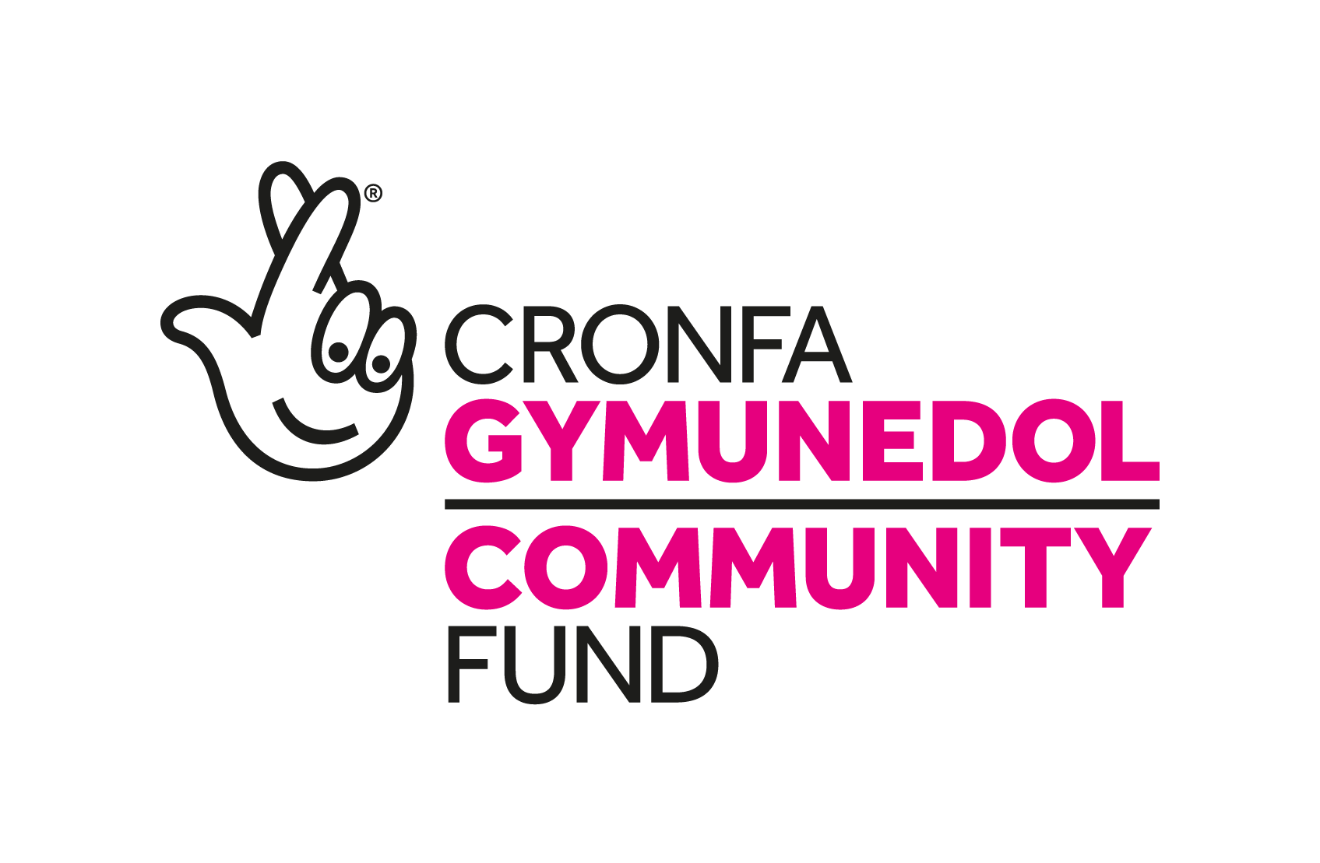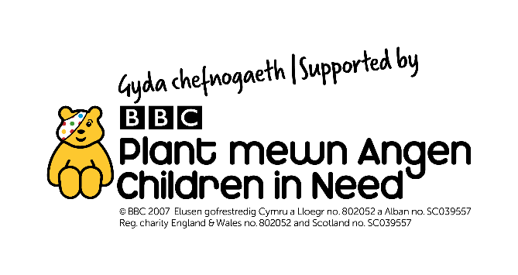
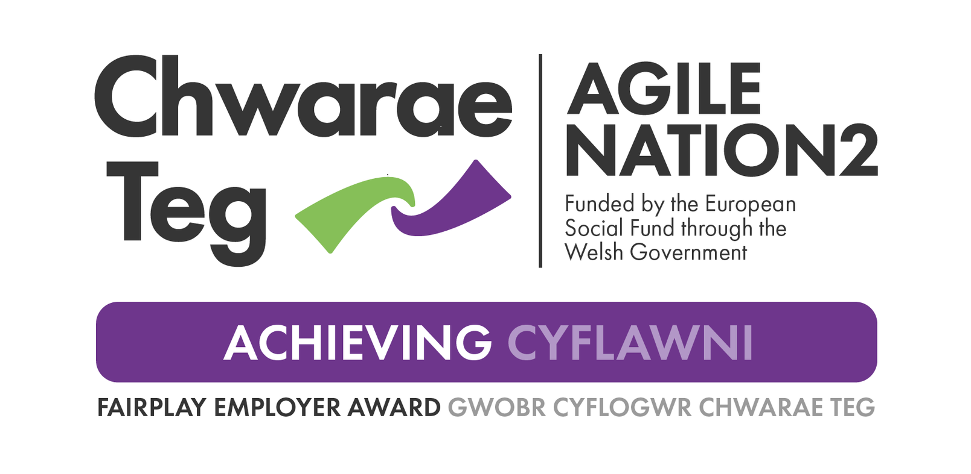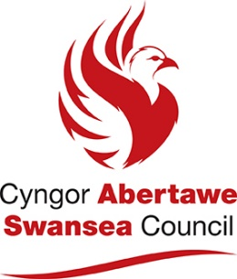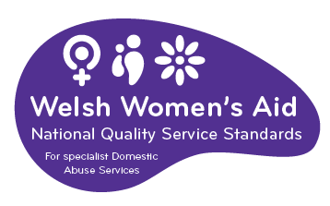

Dear Applicant,

Thank you for your interest in employment with Swansea Women’s Aid. You will find enclosed:

- Job Description and Person Specification
- Application form
- SWA vision, mission and values
- SWA philosophy
- Information sheet
- Project information
- Equal Opportunities Monitoring Form

Please ensure that you follow the guidelines when completing the application form. We operate an equal opportunities recruitment policy and use a pointing system for short-listing. If the application form is not completed as directed, this could mean that you will lose out on points.

Completed application forms should be marked Private and Confidential and can either be returned by post to Swansea Women’s Aid, 28 Bond St, Swansea, SA1 3TU or by email to swa@swanseawa.org.uk.

Additional information regarding Swansea Women’s Aid is available on www.swanseawomensaid.org. and you may find it useful to refer to this site when making your application.

The closing date for applications is 9am on Monday 5TH August 2024. Please note that any applications received after this will not be considered.
Interviews: Week commencing 5th August 2024
Start Date: asap.

Should you require any further information regarding this post, please ring 01792 644683 and ask to speak to Lynne Sanders, Chief Executive.

We wish you every success in your application.

Yours sincerely,

Lynne Sanders
Chief Executive

SWANSEA WOMEN’S AID
JOB DESCRIPTION

Job Title: SWAN Team Leader

Reports to: Chief Executive

Direct Reports : 1 x Senior Support Worker, 1 x ISVA, 2 x Support Workers, 1 x Outreach Shift Leader, 1 x Volunteer Coordinator, 2 x Administration Worker

Main Purposes of the Role

To develop and manage the Support, Wellbeing, Advocacy and eNablement (SWAN) Project provision to meet organisational, project specific and social objectives within agreed budget and standards.

Core Team Leader Responsibilities:
Strategic and Operational Management

- Using knowledge, evidence and experience gained from managing SWA project/service, assist the Chief Executive to develop long term strategic business plans which anticipate and respond to external drivers and context, e.g. expand existing services, propose new services.

- Manage projects/services, within agreed budgets, to deliver to agreed standards and funding parameters and in line with the business plans.

- Assist the Chief Executive to determine the appropriate budget for SWA projects and ensure that financial systems and procedures support the effective management of any activity/project, and that all policies and procedures are adhered to.

- Develop and implement effective strategies for the active participation of service users in the development and management of services.

- Ensure that all reporting requirements both internal and external are met to agreed standards.

- Provide cover for the Chief Executive and other Team Managers when required and to the extent that training and experience allow.

- Contribute, with other Team Managers, to the management of an up-to-date database system of information and resources and develop, implement, and maintain effective and efficient administrative systems for SWA projects.

- Draft, deliver, evaluate and develop training for service users, colleagues and partner organisations to promote the underlying principles of the organisation and assist in the skills/ knowledge improvement of all groups as required.

- Represent the organisation at key external meetings, public events, conferences and similar when necessary, ensuring that the reputation of SWA is protected and enhanced.

- Manage and address complaints, compliments, feedback and suggestions from service users and others effectively and in accordance with procedures and best practice, collating and using this information to feed into continuous service improvement.

- Ensure that service users adhere to the service users contract and remit of the project and address any difficulties according to the relevant policies and procedures and with regards to best practice

Leadership

- Build, lead and motivate a staff team, creating an environment and culture which attract, inspire, and retain high quality people.

- Ensure the team is equipped at all times with high calibre individuals who are appropriately trained and are effectively utilised.

- Appraise and motivate staff informally on a regular basis and formally at least once per year. Identify training and development needs, arrange cost effective training to be provided as necessary.
- Communicate regularly with team using established SWA practices for staff communication (e.g. supervision, team meetings etc.) to review progress, manage performance and communicate objectives etc.

Project/service specific responsibilities:

Relationship Management

- Build, maintain, and manage constructive professional relationships with external partners, stakeholders, and/or funders. Actively seek to develop and manage mutually beneficial strategic partnerships with other agencies and organisations.
- Work strategically to develop appropriate referral pathways into and out of the SWAN Project which maximise the project’s resources and achieve better outcomes for women exploited by the sex industry.
- Liaise closely with organisations providing volunteers which benefit the SWAN outreach service to ensure services provided are consistent, of high quality and maximum benefit to the women who use them.

Quality Management

- Ensure that staff and volunteers involved in the SWAN project are provided with relevant and up to date training in relation to women exploited by the sex industry to guarantee best practice and ensure a trauma informed response to the women accessing the project.
- Work with the Chief Executive to maintain a user-friendly monitoring and evaluation system which includes the input of service users and can be used to inform progress and development opportunities.
- Work with the Chief Executive to maintain ongoing accreditation requirements.

General Duties:
- To demonstrate and promote the organisation’s ethos of informed choice, and its vision and values

- Continually review and develop systems, processes, policies and procedures to ensure that SWA demonstrates quality and best practice at all times.

- To ensure the safety and security (as far as is reasonably practicable) of service users and staff by carrying out risk assessments/health and safety audits, ensuring responsibilities are clearly understood, legislative requirements are adhered to and ensuring that a proactive and professional approach is adopted to Health and Safety issues at all times.
.
- To work in accordance with policy and procedures and the aims and objectives of Swansea Women’s Aid and keep up-to-date with changes in legislation that will affect women and children who are/or have experienced VAWDASV (Violence Against Women, Domestic Abuse and Sexual Violence).

- Carry out and ‘ad hoc’ assignments as may reasonably fall within the scope of the job

- To actively implement SWA policies for anti-discriminatory practice and equality of opportunity

- To work in line with the organisation’s quality assurance processes/systems

Statement of Flexibility:

- It may be necessary, following consultation, to amend the job description in light of experience and changing circumstances.

- The post holder will be required to work evenings and weekends on a regular basis.

- The post holder is required to participate in the organisation’s 24 hours on-call as back-up on a rota basis

PERSON SPECIFICATION

Job Title: SWAN Support Worker

Reports to: Project Team Leader

Direct Reports: None

Essential Characteristics

Education/knowledge (address these on application form)
- Experience of working and managing risk with vulnerable people for a minimum of 1 year in a paid or voluntary capacity.
- Knowledge and understanding of safeguarding issues.
- Knowledge and understanding of the risks involved in working with people at risk of exploitation.
- An understanding of the causes and the long term effects of violence against women, domestic abuse and sexual violence.
- A clear understanding of boundaries within support work.
- An understanding of service user participation and how to engage them in productive and meaningful dialogue in relation to project review and development.

Experience (address these on application form)
- Experience of support planning and review and managing a caseload.
- Experience of working with women with differing social and emotional needs and from varied backgrounds.
- Experience of working with people who are vulnerable to grooming and sexual exploitation.

Other (address this on application form)
1. A full valid driving license with use of car for work.

Skills and Abilities (address this on application form)
- Ability to liaise, network and advocate.
- Good communication skills, both written and verbal.
- Good administrative skills-i.e. filing systems, record keeping, databases and petty cash systems.
- I.T skills – ability to use basic programmes.
- Good organisational skills, i.e. ability to prioritise.
- Ability to work as part of a team and on own initiative.
- Ability to develop effective working relationships with other partner agencies.
- Ability to work under pressure.
- Ability to undertake risk assessment with regards to yourself, co-workers and service users.

Personal Attributes (to be discussed at interview stage)

- Active listening skills to gain rapport quickly with service users.
- A positive ‘can do’ attitude.
- Confidence and assertiveness to deal with challenging situations.
- A commitment to working in a non-judgmental person centered way which promotes respect and empowerment and embraces equality and diversity.
- An awareness and commitment to the principle of self-help.
- Ability to work evenings and weekends as required and to participate in the SWA 24 hour on-call rotas.

Strongly Desirable Characteristic (to be discussed at interview stage)

  - Ability to speak Welsh

Desirable Characteristics (to be discussed at interview stage)

- ISVA qualified
- Ability to speak another language.
- Good understanding, experience or qualification in the following.
- Mental Health
- Drug/Alcohol
- Housing

PRIVATE AND CONFIDENTIAL

SWANSEA WOMEN’S AID
APPLICATION FORM

POST: SWAN TEAM LEADER

PERSONAL DETAILS

Name: ………………………………………….

Address:…………………………………………………………………..

…………………………………………………………………………………...

…………………………………………………Post code: ……………………

Tel No: (Day)…………………………… (Eve)…………………………….

E Mail address:………………………………………..
Please note if your daytime tel. no is your present employment: If we need to ring you in relation to this post, we will not disclose this.

Please give the name of two referees, one of whom must be your recent/previous employer. Please note that references will only be taken up when an offer of employment is made

Name…………………………………. Name………………………………………

Position………………………………. Position……………………………………

Address………………………………. Address……………………………………

………………………………………... …………………………………………….

……………………………………….. …………………………………………….

Postcode……………………………… Postcode………………………………….
Email: Email:

Successful appointment is subject to satisfactory references and an enhanced Disclosure and Barring Service Check (DBS)

Under the Equality Act 2010 pursuant to Schedule 9, Part 1, this is a woman only post

Question 1

EMPLOYMENT HISTORY
As an organisation, SWA attaches equal value to experience gained through both paid and voluntary employment.
DATES  FROM TO | EMPLOYER’S NAME & ADDRESS | POSITION HELD & DUTIES | SALARY & REASON FOR LEAVING

Question 2
SWA is interested in any formal or informal qualifications that you may have, particularly those relevant to this post. Please also include details of any relevant training undertaken.

QUALIFICATIONS
DATES  FROM TO | SCHOOL,COLLEGE, UNIVERSITY ETC | QUALIFICATION &/OR COURSE NAME
TRAINING COURSES/SEMINARS ATTENDED
DATE ATTENDED | ORGANISING BODY | DETAILS OF COURSE/SEMINAR including any certification awarded

Question 3
With reference to the Person Specification for the post, please explain and provide examples of how you meet the following essential characteristics as detailed in the job description and personal specification for this role; education/knowledge, experience, other. (The personal attributes, strongly desirable and desirable characteristics will be discussed at interview stage).
Please ensure you follow the guidelines relating to question 3 on the ‘filling in the form guidelines’ page below. Please attach a continuation sheet if needed.
Question 4
Please give brief details of your personal interests and hobbies, particularly where they illustrate the use of skills and personal qualities relevant to the post.

Question 5
COMPUTER LITERACY
Do you have any experience of using work processors/computers?

YES / NO

If YES, please give details of software packages used:

Question 6
Please tell us of any dates when you would not be available for interview: ……………………

DECLARATION
I certify that all the information provided in this application form is true, accurate and complete to the best of my knowledge and that I have the right to work in the United Kingdom. I understand that should this not be the case, then it may put any offer of employment made by SWA in jeopardy, or result in dismissal.

SIGNED: …………………………… DATED: ……………………

ON COMPLETION, PLEASE RETURN THIS APPLICATION FORM, MARKED PRIVATE AND CONFIDENTIAL TO:

Recruitment,
Swansea Women’s Aid.
28 Bond St,
Swansea,
SA1 3TU.

OR

By email to swa@swanseawa.org.uk

Applications must reach us by the closing date for this post: 9am on Monday 5TH August 2024

Data Protection/GDPR
You will either have sent your personal data directly to us or to a third party agency. However, your application is sent, it will be received by an authorised Administrator. Who will separate the application form from the Equal Opportunity form, log that your application has been received and pass your application form to the Recruitment Officer. The Administrator plays no role in the selection process but will be given your contact details to advise you of the progress of your application, as advised by the Recruitment Officer.

All information held about you is treated as confidential, protected by passwords /locked files, as appropriate and access strictly restricted to nominated persons and will be deleted, as soon as possible and within 6 months of completion of the recruitment process.

The Administrator collates and anonymises the equal opportunities monitoring data to provide general statistics relating to SWA’s equal opportunities performance, which may be reviewed by the Senior Team, Board and or funders it will not be used for any other purpose.

The data on your application form will only be viewed by the Recruitment Officers and used for selection purposes only. It will not be passed on to any other person/third party or used for any other person.

Only successful candidate’s application will be retained and it will be retained for the duration of employment to be destroyed 6 months after the individual has left the Organization.

We take our responsibility to protect your personal data seriously and if you have any queries or concerns or wish to amend any of the information provided you can raise these to the appropriate person. Please see www.swanseawomensaid.com for SWA’s Privacy Policy.

Please indicate below where you saw the job advertisement for this post:

………………………………………………………………………………………………..
E.g. Job Centre, Charity Job Finder, Recruit 3, SWA website etc.

Filling in the form guidelines

If you have a communication difficulty such as dyslexia, please make us aware of this.

Pointing system

In order to reach the shortlist, an applicant must meet ALL of the essential criteria in the Person Specification. Each essential criterion carries points of 0 to 3. Each desirable criterion carries points of 0 to 1. If an applicant points zero on any of the essential criteria, they will not be considered for the shortlist, even if the applicant pointed highly elsewhere. Applicants who are short-listed generally point between 2 & 3 on each essential criterion. Applicants do not need to score on the desirable criteria to be short- listed.

To score between 2 & 3, an applicant must outline their experience / ability and then demonstrate.

For example, a question in the application form asks about applicant’s organisational skills. An applicant may state that in all their jobs they have been required to have good organisational skills (Outlining experience). Demonstrate this by telling us how you developed them, for example, ‘through work where I was required to…’ or, ‘through training / voluntary work / education, it was essential to…’

It is essential when answering Question 3 that you ensure you address each of the stipulated essential criterion. The easiest way to ensure this is to use the headings and numberings as follows:

For example, (N.B. please use criterion on the person specification relating to the role you are applying for, not examples below)
- Experience of working with women (and children) with differing social and emotional needs.
Answer

- An awareness and an understanding of the differing experiences of different cultural and social backgrounds.
Answer

- An understanding/experience of the causes and the long term effects of domestic abuse.
Answer

This advice may seem a bit basic but it is surprising how often applicants can focus on certain essential criteria and fall short on others. We want all applicants to have the best possible opportunity to highlight the required experience and skills to work effectively within this post.

SWANSEA WOMEN’S AID

Vision
A world where women and children are free from abuse

Mission statement

Supporting and empowering women and children to live free from domestic violence and abuse in all its forms.

Key principle
SWA recognises that violence against women, domestic abuse and sexual violence are gender-based forms of violence that are the cause and consequence of gender inequality.

Values
Excellence – in all we do and how we do it
Equality –non-discriminatory and non-judgemental
Diversity – everyone welcomed and valued
Women and children at the heart of all we do – being supported, informing and directing services
Innovation – in service delivery and planning
Integrity - honesty, reliability, trustworthiness
Empowerment – encouraging women and children to reach their full potential
Confidential – respecting privacy and lawful
Collaborative – working with others to change things for the better

SWANSEA WOMEN’S AID - PHILOSOPHY

Women only
Swansea Women’s Aid is part of the wider Women’s Aid movement, run by women for women. We believe that in order to develop confidence and self-esteem, women need ‘space’ to identify their strength and weaknesses away from male influence. Sexism serves not only to systematically undermine and abuse women but also to divide women and alienate them from each other. We feel that the ‘space’ that Women’s Aid provides for women allows them to define themselves according to their own needs and not according to the attitudes of society.

Admissions
Refuge and Safe House space is there for all women who are experiencing domestic violence and are afraid to live in their own homes. We do not discriminate against any woman on grounds of race, religion, sexual orientation or disability. If our Refuge or Safe Houses in Swansea are full, we will contact other groups throughout Wales until Refuge space is found.

Self Help
It is essential to our work to provide a place of safety where women can determine their own future. Women staying in the Refuge are responsible for the day to day running of the house. We believe that it is crucial that women are given the space to rebuild their confidence so that they can resume responsibility for their lives in an atmosphere of mutual respect and co-operation. Women’s Aid supports women in this development at whatever stage individual women are at any time.

SWANSEA WOMEN’S AID
INFORMATION SHEET

JOB TITLE: SWAN Team Leader

HOURS OF WORK: Part time 28 hours
This post is primarily office based. The demands of the service will require you to participate in the evening outreach service on a rota basis. Any overtime will be compensated for by time in lieu.

SALARY: £23,906

CONTRACT LENGTH: This post is funded to 30th June 2027.

HOLIDAY ENTITLEMENT: 25 days per year, plus 9 bank holidays Pro rata

PROBATIONARY PERIOD: Six months

PENSION: Swansea Women’s Aid contributes 6% of the basic annual salary into the Swansea Women’s Aid qualifying workplace pension scheme.

OTHER:

All workers are required to undergo an enhanced DBS check.

The post holder will manage the SWAN Project team and report to the Chief Executive.

Swansea Women’s Aid is a women-only organisation with both paid and unpaid workers and is affiliated to Welsh Women’s Aid.

The post holder will participate in the 24-hour on call rota on evenings and weekends. This will include out-of-hours admissions into the refuge and safe houses and call outs to deal with housing management issues..

SWA value diversity and are committed to promoting equality. We encourage applications from women from all backgrounds and communities – Black, Asian, LGTBQ+ or other ethnic minority backgrounds and people with a disability.

We particularly welcome applications from Welsh speaking candidates.

SWAN PROJECT
This project provides a holistic women centered service that is responsive to the needs of women exploited by the sex industry, particularly those street sex working in Swansea but also taking into account emerging online sectors and migrant workers.

The work focuses on:
- Providing a dedicated crisis response for women exploited by the sex industry (WESI)
- Providing evening outreach and daytime support to engage with WESIs.
- Supporting by assessing needs, triaging and referring/accompanying to relevant support services
- Advocating and supporting to assist with maintained engagement
- Monitoring and recording online work, engaging with specialist agencies to develop appropriate support responses
- Promoting and strengthening the local multi-agency support infrastructure and its response to WESI support and engagement
- Co-working initiatives with the police

Who?
Staff act as trusted links between police, local support agencies and WESIs. Other SWA staff will provide additional emotional and practical support, including from our DAISE Family Support project and (where relevant) 2 refuges and 3 safe houses.

Additionally, a Volunteer Coordinator and an Admin worker will provide the support to enable a 4 day per week outreach programme.

Where and when?
Staff will be based in our central office which can also serve as a 1:1 appointment venue.

SWA
Equal Opportunities Monitoring Form

In accordance with our equal opportunities policy, SWA will provide equality of opportunity to all employees and job applicants and will not discriminate either directly or indirectly on the grounds of race, sex, gender identity, marital status, disability, sexual orientation, pregnancy or maternity, religion/belief or age.

Your assistance is requested to allow us to monitor the effectiveness of our Equal Opportunities Policy by completing and returning this form. Please note that the monitoring form does not form part of your role, stored in a confidential file and will not be available to the wider management team.

On receipt, the Office Manager will compile anonymous statistics. Personal information will not be shared and all forms will be destroyed after 3 months. The information you provide will not be used for any other purpose than to monitor the effectiveness of the equal opportunities policy, anonymous monitoring statistics may only be reviewed by the Board and or our funders.

Personal Details:
Please tick the boxes that are relevant to you and complete all sections
1.Age | Under16 ☐ | 16-24 ☐ |  |  | 25-34 ☐ |  | 35-44 ☐ |  |  | 45-54 ☐
 | 55-64 ☐ | 65+ ☐
Prefer not to state Age | ☐
2. Sex | Male ☐ |  |  |  |  | Female ☐
Prefer not to state | ☐
Gender Identity (options) | If you identify as transsexual, transgender (in that you have effected a permanent change of gender identity) or as intersex which group do you identify with?
Gender Identity (options) | Transsexual ☐ |  |  | Transgender ☐ |  |  |  |  | Intersex ☐
3.Marritial / Relationship status | Single ☐  Married/civil partnership ☐  Divorced ☐ |  | Co habiting ☐  Same sex civil partnership☐  Widowed ☐ |  |  |  |  | Engaged ☐  Separated ☐  Prefer not to say ☐

4.Pregnancy and Maternity

I am pregnant/adopting a child Yes ☐ No ☐ Prefer not to say ☐

I have had a child in the past 12 months Yes ☐ No ☐ Prefer not to say ☐

5.Sexual Orientation: Please tick against one of the following

Bisexual | ☐
Gay Woman / Lesbian | ☐ | Heterosexual / Straight | ☐
Other | ☐ | Prefer not to say | ☐

6.Religion or belief: Please tick against one of the following

No religion | ☐ | Buddhist | ☐ | Christian | ☐
Hindu | ☐ | Jewish | ☐ | Muslim | ☐
Sikh | ☐ | Prefer not to say | ☐
Other | ☐ | Please state:

7.Ethnic origin: Please tick against one of the following

Asian/  Asian British; | Bangladeshi | ☐
Asian/  Asian British; | Chinese | ☐
Asian/  Asian British; | Indian | ☐
Asian/  Asian British; | Pakistani | ☐
Asian/  Asian British; | Other Asian | ☐
Black/African/Caribbean/  Black British; | African | ☐
Black/African/Caribbean/  Black British; | Caribbean | ☐
Black/African/Caribbean/  Black British; | Other Black | ☐
Mixed/  Multiple Ethnic Groups; | White & Asian | ☐
Mixed/  Multiple Ethnic Groups; | White & Black African | ☐
Mixed/  Multiple Ethnic Groups; | White & Black Caribbean | ☐
Mixed/  Multiple Ethnic Groups; | Other Mixed | ☐
Other Ethnic Group; | Arab | ☐
Other Ethnic Group; | Any Other Ethnic Group | ☐
White; | English/Welsh/Scottish/Northern Irish/British | ☐
White; | Gypsy or Irish Traveller | ☐
White; | Irish | ☐
White; | Other White  Prefer not to say | ☐
 | Other White  Prefer not to say | ☐
8.Disability: Please tick against one of the following

Disability definition under the Equality Act 2010
In the Act, a person has a disability if:
- they have a physical or mental impairment
- the impairment has a substantial and long-term adverse effect on their ability to perform normal day-to-day activities
- For the purposes of the Act, these words have the following meanings:
- 'substantial' means more than minor or trivial
- 'long-term' means that the effect of the impairment has lasted or is likely to last for at least twelve months (there are special rules covering recurring or fluctuating conditions)
- 'normal day-to-day activities' include everyday things like eating, washing, walking and going shopping
People who have had a disability in the past that meets this definition are also protected by the Act.

Progressive conditions considered to be a disability
There are additional provisions relating to people with progressive conditions. People with HIV, cancer or multiple sclerosis are protected by the Act from the point of diagnosis. People with some visual impairment are automatically deemed to be disabled.

Conditions that are specifically excluded
Some conditions are specifically excluded from being covered by the disability definition, such as a tendency to set fires or addictions to non–prescribed substances.

Do you consider yourself to have a disability according to the terms above?

Yes ☐ No ☐ Prefer not to say ☐

If you have answered yes, please indicate the type of impairment which applies to you. If your experience more than one type of impairment, please tick all the types that apply. If your disability does not fit any of these types, please circle Other and specify.
Physical/mobility impairment, such as a difficulty using your arms or mobility issues which require you to use a wheelchair or crutches
Visual impairment, such as being blind or having a serious visual impairment
Hearing impairment, such as being deaf or having a serious hearing impairment
Mental health condition, such as depression or schizophrenia
Learning disability/difficulty, such as Down’s syndrome or dyslexia or a cognitive impairment such as autistic spectrum disorder
Long-standing illness or health condition, such as cancer, HIV, diabetes, chronic heart disease or epilepsy

Other (Please specify below)

This information is provided for monitoring purposes only – if you need reasonable adjustments you should arrange these separately as this form will not be seen by Team Leaders.

9.Languages

What Is your first language?

English ☐ Welsh ☐ Other ☐ please state:

Do you speak any other languages?

No ☐

Yes ☐ please state:

Thank you for taking the time to complete the information requested on this form, and thereby enabling us to monitor the effectiveness of our equal opportunities policy.

