SWANSEA WOMEN’S AID
APPLICATION PACK

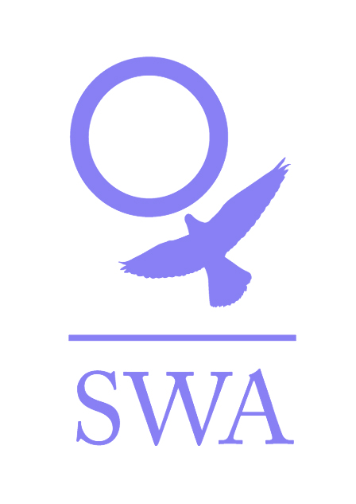

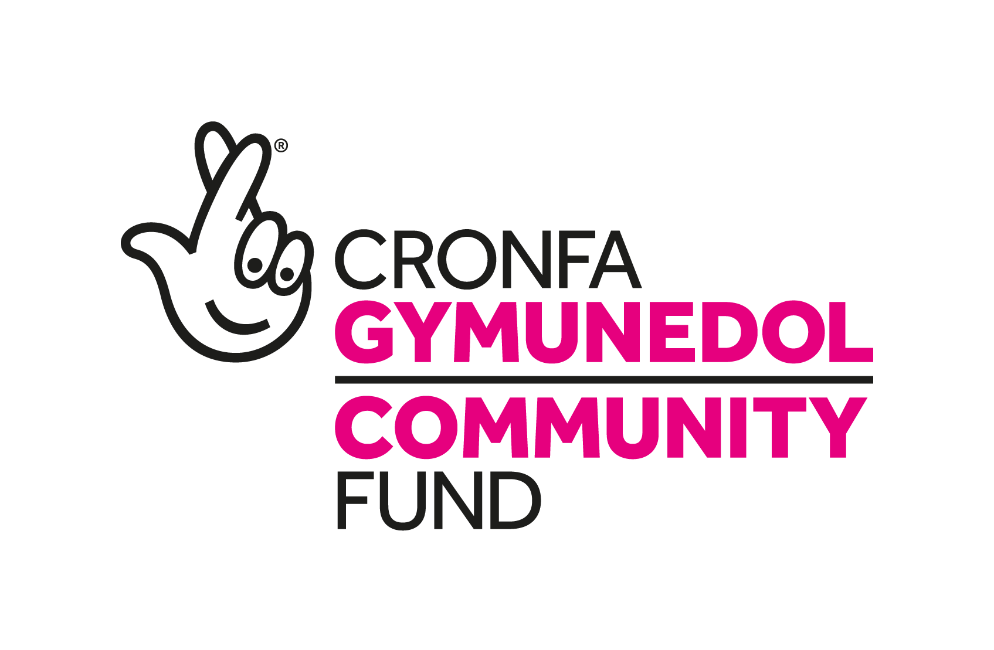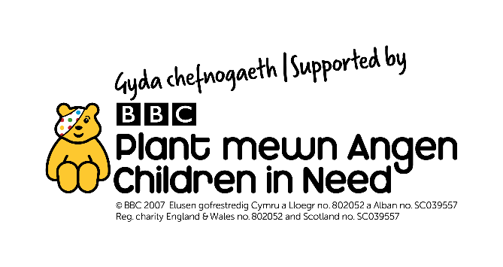
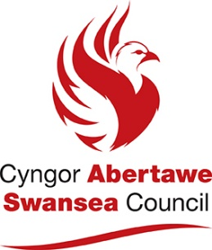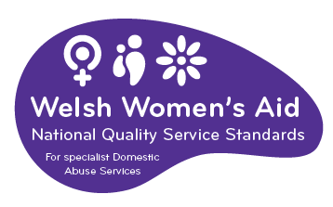

Dear Applicant,

Thank you for your interest in employment with Swansea Women’s Aid. You will find enclosed:

- Job Description and Person Specification
- Application form
- SWA vision, mission and values
- SWA philosophy
- Information sheet
- Project information
- Equal Opportunities Monitoring Form

Please ensure that you follow the guidelines when completing the application form. We operate an equal opportunities recruitment policy and use a pointing system for short-listing. If the application form is not completed as directed, this could mean that you will lose out on points.

Completed application forms should be marked Private and Confidential and can either be returned by post to Swansea Women’s Aid, 28 Bond St, Swansea, SA1 3TU or by email to swa@swanseawa.org.uk.

Additional information regarding Swansea Women’s Aid is available on www.swanseawomensaid.org. and you may find it useful to refer to this site when making your application.

The closing date for applications is 9am on Monday 5TH August 2024. Please note that any applications received after this will not be considered. Interviews will take place week commencing 5th August 2024.

Should you require any further information regarding this post, please ring 01792 644683 and ask to speak to Kerry Jones, Office manager Chief Executive.

We wish you every success in your application.

Yours sincerely,

Lynne Sanders
Chief Executive

SWANSEA WOMEN’S AID
JOB DESCRIPTION

Job Title: SWAN Administration Worker

Reports to: SWAN Team Leader

Direct Reports: none

Main Purpose of the Role
To support the SWAN Project at SWA by undertaking core administrative tasks on a day-to-day basis and providing administrative support to the SWAN support team and Volunteer Coordinator as and when required.

Specific Responsibilities:
- Record and distribute all incoming and outgoing Volunteering posts.
- Answering the phone and directing phone calls to the relevant staff, supporting the SWAN team by booking appointments & sending out information.
- Distribution of SWAN outreach rota’s on a monthly basis, liaising with volunteers, staff and managers as appropriate. Updating the SWAN outreach calendar to ensure an accurate record of outreach duties.
- Perform administrative tasks as directed by the SWAN Team Leader e.g. writing out cash requisition forms, preparing petty cash paperwork for remittance.
- Purchasing of stationery, printer ink, office supplies.
- Maintenance of systems e.g. volunteer files and update of service users case files as appropriate.
- Maintenance of project databases to ensure provision of statistical information including volunteer rota database.
- Assist with monitoring and evaluation requirement of the project as directed by the SWAN Team Leader.
- Collate data and information required for reporting purposes
- Assist project workers with the organisation of service user activities
- Maintain all paperwork and legal requirements of the organisational transport e.g. road tax, insurance and repairs.
- Ensure all transportation safety check paperwork is completed and filed
- Ensure all administration of paperwork for EDBS checks are prepared in order to aid the Volunteer Coordinator in applying to UCheck.
- Prompt return of any paperwork to volunteers.
- Manage own diary and liaise with Volunteer Coordinator to book appointments in her diary e.g. in order to complete disclosure and barring service checks.
- Undertake an audit of the literature and resources available for SWAN and, after review, ensure that all the required resources are in place and catalogued.
- Maintain appropriate levels of SWAN publicity materials and assist in its distribution.
- Take minutes of any SWAN Meetings and other meetings as directed by the SWAN Team Leader or Chief Executive.
- Undertake ad hoc administrative tasks as directed.

General
- Demonstrate and promote the organisation’s ethos of informed choice, and its vision and values.
- Participate in team meetings, supervision and appropriate training
- Work in accordance with SWA Policies and Procedures and standards and overall aims and objectives of SWA.
- Undertake any other reasonable duties as required by the SWAN Team Leader.
- Proactively implement SWA policies for anti-discriminatory practice and equality of opportunity, ensuring that services are available for and meet the needs of all e.g. minority and disabled women etc.
- To carry out any other ad hoc duties that reasonably fall within the remit of this role

Person Specification: (the skills, experience and qualities which are expected from Administration Workers)

Essential Characteristics

Personal and Administrative skills
- Good communication skills both written and verbal.
- Experience of administrative skills-i.e. filing systems, record keeping, databases and petty cash systems.
- I.T skills – ability to use basic programmes.
- Ability to work as part of a team and on own initiative.
- Good organisational skills – i.e. ability to prioritise.
- An awareness and commitment to the principle of empowerment and self-help.
- Ability to work within any SWA office

Desirable

- A full valid driving licence.
Ability to speak Welsh or other language

SWANSEA WOMEN’S AID
APPLICATION FORM

POST: SWAN ADMINISTRATION WORKER

PERSONAL DETAILS

Name: ………………………………………….

Address:……………………………………………………………………..

…………………………………………………………………………………...

…………………………………………………Post code: ……………………

Tel No: (Day)…………………………… (Eve)………………………….

E Mail address:…………………………………………..
Please note if your daytime tel. no is your present employment: If we need to ring you in relation to this post, we will not disclose this.

Please give the name of two referees, one of whom must be your recent/previous employer. Please note that references will only be taken up when an offer of employment is made

Name…………………………………. Name………………………………………

Position………………………………. Position……………………………………

Address………………………………. Address……………………………………

………………………………………... …………………………………………….

……………………………………….. …………………………………………….

Postcode……………………………… Postcode………………………………….
Email: Email:

Successful appointment is subject to satisfactory references and an enhanced Disclosure and Barring Service Check (DBS)

Under the Equality Act 2010 pursuant to Schedule 9, Part 1, this is a women only post

Question 1

EMPLOYMENT HISTORY
As an organisation, SWA attaches equal value to experience gained through both paid and voluntary employment.
DATES  FROM TO | EMPLOYER’S NAME & ADDRESS | POSITION HELD & DUTIES | SALARY & REASON FOR LEAVING

Question 2
SWA is interested in any formal or informal qualifications that you may have, particularly those relevant to this post. Please also include details of any relevant training undertaken.

QUALIFICATIONS
DATES  FROM TO | SCHOOL,COLLEGE, UNIVERSITY ETC | QUALIFICATION &/OR COURSE NAME
TRAINING COURSES/SEMINARS ATTENDED
DATE ATTENDED | ORGANISING BODY | DETAILS OF COURSE/SEMINAR including any certification awarded
Question 3
With reference to the Person Specification for the post, please explain and provide examples of how you meet the essential and desirable criteria. Please attach a continuation sheet if needed.
Question 4
Please give brief details of your personal interests and hobbies, particularly where they illustrate the use of skills and personal qualities relevant to the post.

Question 5
COMPUTER LITERACY
Do you have any experience of using work processors/computers?

YES / NO

If YES, please give details of software packages used:

Question 6
Please tell us of any dates when you would not be available for interview: ……………………

DECLARATION
I certify that all the information provided in this application form is true, accurate and complete to the best of my knowledge and that I have the right to work in the United Kingdom. I understand that should this not be the case, then it may put any offer of employment made by SWA in jeopardy, or result in dismissal.

SIGNED: …………………………… DATED: ……………………

ON COMPLETION, PLEASE RETURN THIS APPLICATION FORM, MARKED PRIVATE AND CONFIDENTIAL TO:

The Chief Executive,
Swansea Women’s Aid.
28 Bond St,
Swansea,
SA1 3TU.

OR

By email to swa@swanseawa.org.uk

Applications must reach us by the closing date for this post: 9am on Monday 5TH August 2024

Data Protection/GDPR
You will either have sent your personal data directly to us or to a third party agency. However, your application is sent, it will be received by an authorised Administrator. Who will separate the application form from the Equal Opportunity form, log that your application has been received and pass your application form to the Recruitment Officer. The Administrator plays no role in the selection process but will be given your contact details to advise you of the progress of your application, as advised by the Recruitment Officer.

All information held about you is treated as confidential, protected by passwords /locked files, as appropriate and access strictly restricted to nominated persons and will be deleted, as soon as possible and within 6 months of completion of the recruitment process.

The Administrator collates and anonymises the equal opportunities monitoring data to provide general statistics relating to SWA’s equal opportunities performance, which may be reviewed by the Senior Team, Board and or funders it will not be used for any other purpose.

The data on your application form will only be viewed by the Recruitment Officers and used for selection purposes only. It will not be passed on to any other person/third party or used for any other person.

Only successful candidate’s application will be retained and it will be retained for the duration of employment to be destroyed 6 months after the individual has left the Organization.

We take our responsibility to protect your personal data seriously and if you have any queries or concerns or wish to amend any of the information provided you can raise these to the appropriate person. Please see www.swanseawomensaid.com for SWA’s Privacy Policy.

Please indicate below where you saw the job advertisement for this post:

………………………………………………………………………………………………..
E.g. Job Centre, Charity Job Finder, Recruit 3, SWA website etc.

Filling in the form guidelines

If you have a communication difficulty such as dyslexia, please make us aware of this.

Pointing system

In order to reach the shortlist, an applicant must meet ALL of the essential criteria in the Person Specification. Each essential criterion carries points of 0 to 3. Each desirable criterion carries points of 0 to 1. If an applicant points zero on any of the essential criteria, they will not be considered for the shortlist, even if the applicant pointed highly elsewhere. Applicants who are short-listed generally point between 2 & 3 on each essential criterion. Applicants do not need to score on the desirable criteria to be short- listed.

To score between 2 & 3, an applicant must outline their experience / ability and then demonstrate.

For example, a question in the application form asks about applicant’s organisational skills. An applicant may state that in all their jobs they have been required to have good organisational skills (Outlining experience). Demonstrate this by telling us how you developed them, for example, ‘through work where I was required to…’ or, ‘through training / voluntary work / education, it was essential to…’

It is essential when answering Question 3 that you ensure you address each of the stipulated essential criterion. The easiest way to ensure this is to use the headings and numberings as follows:

For example
- Experience of working with women (and children) with differing social and emotional needs.
Answer

- An awareness and an understanding of the differing experiences of different cultural and social backgrounds.
Answer

- An understanding/experience of the causes and the long term effects of domestic abuse.
Answer

This advice may seem a bit basic but it is surprising how often applicants can focus on certain essential criteria and fall short on others. We want all applicants to have the best possible opportunity to highlight the required experience and skills to work effectively within this post.

SWANSEA WOMEN’S AID

Vision
A world where women and children are free from abuse

Mission statement

Supporting and empowering women and children to live free from domestic violence and abuse in all its forms.

Values

- Excellence – in all we do and how we do it

- Equality –non-discriminatory and non-judgmental

- Diversity – everyone welcomed and valued

- Women and children at the heart of all we do – being supported, informing and directing services

- Innovation – in service delivery and planning

- Integrity - honesty, reliability, trustworthiness

- Empowerment – encouraging women and children to reach their full potential

- Confidential – respecting privacy and lawful

- Collaborative – working with others to change things for the better

SWANSEA WOMEN’S AID - PHILOSOPHY

Women only
Swansea Women’s Aid is part of the wider Women’s Aid movement, run by women for women. We believe that in order to develop confidence and self-esteem, women need ‘space’ to identify their strength and weaknesses away from male influence. Sexism serves not only to systematically undermine and abuse women but also to divide women and alienate them from each other. We feel that the ‘space’ that Women’s Aid provides for women allows them to define themselves according to their own needs and not according to the attitudes of society.

Admissions
Refuge and Safe House space is there for all women who are experiencing domestic violence and are afraid to live in their own homes. We do not discriminate against any woman on grounds of race, religion, sexual orientation or disability. If our Refuge or Safe Houses in Swansea are full, we will contact other groups throughout Wales until Refuge space is found.

Self Help
It is essential to our work to provide a place of safety where women can determine their own future. Women staying in the Refuge are responsible for the day to day running of the house. We believe that it is crucial that women are given the space to rebuild their confidence so that they can resume responsibility for their lives in an atmosphere of mutual respect and co-operation. Women’s Aid supports women in this development at whatever stage individual women are at any time.

SWANSEA WOMEN’S AID
INFORMATION SHEET

JOB TITLE: SWAN ADMINISTRATION WORKER – Part time

HOURS OF WORK: 15 PER WEEK. Hours are agreed and need to be worked flexibly. Any overtime will be compensated for by time in lieu.

SALARY: £9,360 per annum

CONTRACT LENGTH: This post is funded to 30th June 2027

HOLIDAY ENTITLEMENT: 25 days per year, plus 9 bank holidays pro rata.

PROBATIONARY PERIOD: Three months

PENSION: Swansea Women’s Aid contributes 6% of the basic annual salary into the Swansea Women’s Aid qualifying workplace pension scheme.

OTHER:

All workers are required to undergo an enhanced DBS check.

The post holder will work as part of the SWAN Project team and will report to the Office Manager.

Swansea Women’s Aid is a women-only organisation with both paid and unpaid workers and is affiliated to Welsh Women’s Aid.

Swansea Women’s Aid is an equal opportunities employer and welcomes applications from all sectors of the community.

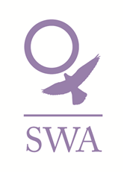
SWAN PROJECT
This project provides a holistic women centered service that is responsive to the needs of women who are exploited by the sex industry, particularly to those street sex working in Swansea but also taking into account emerging online sectors and migrant workers.

The work focuses on:
- Providing a dedicated crisis response for women exploited by the sex industry (WESI)
- Providing evening outreach and daytime support to engage with WESIs.
- Supporting by assessing needs, triaging and referring/accompanying to relevant support services
- Advocating and supporting to assist with maintained engagement
- Monitoring and recording online work, engaging with specialist agencies to develop appropriate support responses
- Promoting and strengthening the local multi-agency support infrastructure and its response to WESI support and engagement
- Co-working initiatives with the police

Who?
2.5 full-time staff act as trusted links between police, local support agencies and WESIs.
Additionally, 1 Volunteer Coordinator and an Admin worker will provide the support to enable a 4 day per week outreach programme.

Other SWA staff will provide additional emotional and practical support, including from our Domestic Abuse Information, Support & Empowerment (DAISE) project and (where relevant) 2 refuges and 3 safe houses.

Where and when?
Staff will be based in our Central Office at Bond Street which will also serve as a 1:1 appointment venue.

SWA
Equal Opportunities Monitoring Form

In accordance with our equal opportunities policy, SWA will provide equality of opportunity to all employees and job applicants and will not discriminate either directly or indirectly on the grounds of race, sex, gender identity, marital status, disability, sexual orientation, pregnancy or maternity, religion/belief or age.

Your assistance is requested to allow us to monitor the effectiveness of our Equal Opportunities Policy by completing and returning this form. Please note that the monitoring form does not form part of your role, stored in a confidential file and will not be available to the wider management team.

On receipt, the Office Manager will compile anonymous statistics. Personal information will not be shared and all forms will be destroyed after 3 months. The information you provide will not be used for any other purpose than to monitor the effectiveness of the equal opportunities policy, anonymous monitoring statistics may only be reviewed by the Board and or our funders.

Personal Details:
Please tick the boxes that are relevant to you and complete all sections
1.Age | Under16 ☐ | 16-24 ☐ |  |  | 25-34 ☐ |  | 35-44 ☐ |  |  | 45-54 ☐
 | 55-64 ☐ | 65+ ☐
Prefer not to state Age | ☐
2. Sex | Male ☐ |  |  |  |  | Female ☐
Prefer not to state | ☐
Gender Identity (options) | If you identify as transsexual, transgender (in that you have effected a permanent change of gender identity) or as intersex which group do you identify with?
Gender Identity (options) | Transsexual ☐ |  |  | Transgender ☐ |  |  |  |  | Intersex ☐
3.Marritial / Relationship status | Single ☐  Married/civil partnership ☐  Divorced ☐ |  | Co habiting ☐  Same sex civil partnership☐  Widowed ☐ |  |  |  |  | Engaged ☐  Separated ☐  Prefer not to say ☐

4.Pregnancy and Maternity

I am pregnant/adopting a child Yes ☐ No ☐ Prefer not to say ☐

I have had a child in the past 12 months Yes ☐ No ☐ Prefer not to say ☐

5.Sexual Orientation: Please tick against one of the following

Bisexual | ☐
Gay Woman / Lesbian | ☐ | Heterosexual / Straight | ☐
Other | ☐ | Prefer not to say | ☐

6.Religion or belief: Please tick against one of the following

No religion | ☐ | Buddhist | ☐ | Christian | ☐
Hindu | ☐ | Jewish | ☐ | Muslim | ☐
Sikh | ☐ | Prefer not to say | ☐
Other | ☐ | Please state:

7.Ethnic origin: Please tick against one of the following

Asian/  Asian British; | Bangladeshi | ☐
Asian/  Asian British; | Chinese | ☐
Asian/  Asian British; | Indian | ☐
Asian/  Asian British; | Pakistani | ☐
Asian/  Asian British; | Other Asian | ☐
Black/African/Caribbean/  Black British; | African | ☐
Black/African/Caribbean/  Black British; | Caribbean | ☐
Black/African/Caribbean/  Black British; | Other Black | ☐
Mixed/  Multiple Ethnic Groups; | White & Asian | ☐
Mixed/  Multiple Ethnic Groups; | White & Black African | ☐
Mixed/  Multiple Ethnic Groups; | White & Black Caribbean | ☐
Mixed/  Multiple Ethnic Groups; | Other Mixed | ☐
Other Ethnic Group; | Arab | ☐
Other Ethnic Group; | Any Other Ethnic Group | ☐
White; | English/Welsh/Scottish/Northern Irish/British | ☐
White; | Gypsy or Irish Traveller | ☐
White; | Irish | ☐
White; | Other White  Prefer not to say | ☐
 | Other White  Prefer not to say | ☐
8.Disability: Please tick against one of the following

Disability definition under the Equality Act 2010
In the Act, a person has a disability if:
- they have a physical or mental impairment
- the impairment has a substantial and long-term adverse effect on their ability to perform normal day-to-day activities
- For the purposes of the Act, these words have the following meanings:
- 'substantial' means more than minor or trivial
- 'long-term' means that the effect of the impairment has lasted or is likely to last for at least twelve months (there are special rules covering recurring or fluctuating conditions)
- 'normal day-to-day activities' include everyday things like eating, washing, walking and going shopping
People who have had a disability in the past that meets this definition are also protected by the Act.

Progressive conditions considered to be a disability
There are additional provisions relating to people with progressive conditions. People with HIV, cancer or multiple sclerosis are protected by the Act from the point of diagnosis. People with some visual impairment are automatically deemed to be disabled.

Conditions that are specifically excluded
Some conditions are specifically excluded from being covered by the disability definition, such as a tendency to set fires or addictions to non–prescribed substances.

Do you consider yourself to have a disability according to the terms above?

Yes ☐ No ☐ Prefer not to say ☐

If you have answered yes, please indicate the type of impairment which applies to you. If your experience more than one type of impairment, please tick all the types that apply. If your disability does not fit any of these types, please circle Other and specify.
Physical/mobility impairment, such as a difficulty using your arms or mobility issues which require you to use a wheelchair or crutches
Visual impairment, such as being blind or having a serious visual impairment
Hearing impairment, such as being deaf or having a serious hearing impairment
Mental health condition, such as depression or schizophrenia
Learning disability/difficulty, such as Down’s syndrome or dyslexia or a cognitive impairment such as autistic spectrum disorder
Long-standing illness or health condition, such as cancer, HIV, diabetes, chronic heart disease or epilepsy

Other (Please specify below)

This information is provided for monitoring purposes only – if you need reasonable adjustments you should arrange these separately as this form will not be seen by Team Leaders.

9.Languages

What Is your first language?

English ☐ Welsh ☐ Other ☐ please state:

Do you speak any other languages?

No ☐

Yes ☐ please state:

Thank you for taking the time to complete the information requested on this form, and thereby enabling us to monitor the effectiveness of our equal opportunities policy.

