SWANSEA WOMEN’S AID
APPLICATION PACK

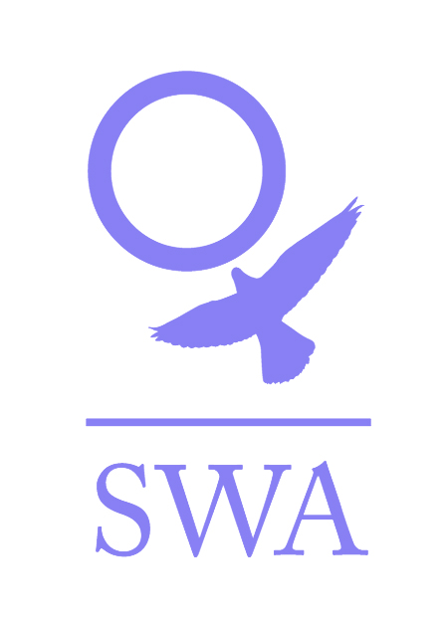

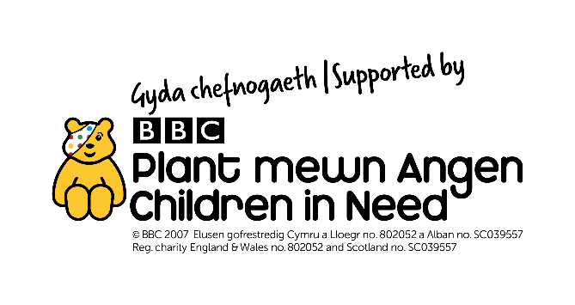

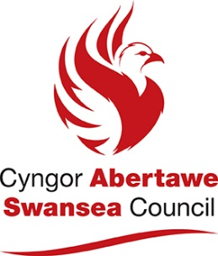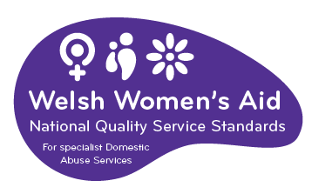

Dear Applicant,

Thank you for your interest in employment with Swansea Women’s Aid. You will find enclosed:

- Job Description and Person Specification
- Application form
- SWA mission statement and banner aims
- SWA philosophy
- Information sheet
- Project information
- Equal Opportunities Monitoring Form

Please ensure that you follow the guidelines when completing the application form. We operate an equal opportunities recruitment policy and use a pointing system for short-listing. If the application form is not completed as directed, this could mean that you will lose out on points.

Completed application forms can either be returned by post to Swansea Women’s Aid, 28 Bond St, Swansea, SA1 3TU or by email to swa@swanseawa.org.uk.

Additional information regarding Swansea Women’s Aid is available on www.swanseawomensaid.org. and you may find it useful to refer to this site when making your application.

The closing date for applications is 9am on Monday, 17th January 2022. Please note that any applications received after this will not be considered.

Interviews will take place on Friday, 21st January 2022.

Should you require any further information regarding this post, please ring 01792 644683 and ask to speak to the CHYPS Team Leader, Lisa Conte

We wish you every success in your application.

Yours sincerely,

Lynne Sanders
Chief Executive

SWANSEA WOMEN’S AID

JOB DESCRIPTION

Job Title: Forest School Project Worker

Reports To: CHYPS Team Leader

Direct Reports: None

Main Purpose of the Role
Deliver the Forest School Project programme of outdoor learning sessions, to support volunteers and co-ordinate the daily operations in an efficient and effective manner.

Responsibilities:

- To deliver Forest School Project outdoor learning sessions in woodland and coastal settings.
- To lead the project programme delivery.
- To support the recruitment and management of volunteers in the project (including marketing for new volunteers, completing induction meetings and arranging training where necessary).
- Plan and prepare for delivery of the project programme.
- Deliver the weekly sessions.
- Plan daily responsibilities for and supervise any volunteers at the sessions.
- Liaise with key workers and parents where appropriate.
- Promote the project among SWA.
- Comply with all SWA policies and procedures at all times, paying particular regard to SWA’s child and adult protection/procedures and health and safety policies and procedures, taking steps to remove immediate risks and reporting any risks/concerns/issues to the appropriate person (e.g. Team Leader/ CEO) in line with SWA policy.

General
- Demonstrate and promote the organisation’s ethos of informed choice and its vision and values at all times.
- Represent the organisation at external events ensuring that SWA’s reputation is protected and enhanced.
- Keep up to date with changes in legislation that will affect women and children who are or have experienced violence against women, domestic abuse and sexual violence (VAWDASV)
- Actively work in partnership with other agencies and organisations to achieve better outcomes for women and children affected by VAWDASV.
- Participate in team meetings, supervision and appropriate training
- Work in accordance with SWA Policies and Procedures and standards and overall aims and objectives of SWA.
- Contribute to the development and review of SWA policies and procedures.
- Proactively implement SWA policies for anti-discriminatory practice and equality of opportunity, ensuring that services are available for and meet the needs of all e.g. minority and disabled women etc.
- Any other reasonable duties as required by the Team Leader.

PERSON SPECIFICATION

SWANSEA WOMEN’S AID

Job Title: Forest School Project Worker

Reports To: CHYPS Team Leader

Direct Reports: None

Essential Characteristics

- Must be over 21 years old and have completed a Level 2 or above qualification working with children and young people (e.g. PGCE, Play work, Youth work etc.)
- Holds a Leading Forest School Level 3 Certificate
- At least 2 years’ experience of working with children and young people.
- Experience of working with and/or supporting volunteers.
- Experience of delivering group activities in a variety of outdoor settings.

Strongly Desirable Characteristic:

- Ability to speak Welsh

Desirable

2. Knowledge and understanding of safeguarding and child protection
procedure, including understanding of appropriate boundaries.
- A good team player able to work as part of a team and on own initiative.
- A positive ‘can do’ attitude.
- A full valid driving licence and use of a car for work.

PRIVATE AND CONFIDENTIAL

SWANSEA WOMEN’S AID
APPLICATION FORM

POST: CHYPS FOREST SCHOOL PROJECT WORKER

PERSONAL DETAILS

Name: ………………………………………….

Address:…………………………………………………………………………..

…………………………………………………………………………………...

…………………………………………………Post code: ……………………

Tel No: (Day)…………………………… (Eve)……………………………..

E Mail address:………………………………………………..
Please note if your daytime tel. no is your present employment: If we need to ring you in relation to this post, we will not disclose this.

Please give the name of two referees, one of whom must be your recent/previous employer. Please note that references will only be taken up when an offer of employment is made

Name………………………………….. Name………………………………………

Position……………………………….. Position……………………………………

Address……………………………….. Address……………………………………

………………………………………... …………………………………………….

……………………………………….. …………………………………………….

Postcode……………………………… Postcode…………………………………..
Email: Email:

Successful appointment is subject to satisfactory references and an enhanced Disclosure and Barring Service Check

Under the Equality Act 2010 pursuant to Schedule 9, Part 1, this is a woman only
Post

Question 1

EMPLOYMENT HISTORY
As an organisation, SWA attaches equal value to experience gained through both paid and voluntary employment.
DATES  FROM TO | EMPLOYER’S NAME & ADDRESS | POSITION HELD & DUTIES | SALARY & REASON FOR LEAVING

Question 2
SWA is interested in any formal or informal qualifications that you may have, particularly those relevant to this post. Please also include details of any relevant training undertaken.

QUALIFICATIONS
DATES  FROM TO | SCHOOL,COLLEGE, UNIVERSITY ETC | QUALIFICATION &/OR COURSE NAME
TRAINING COURSES/SEMINARS ATTENDED
DATE ATTENDED | ORGANISING BODY | DETAILS OF COURSE/SEMINAR including any certification awarded

Question 3
With reference to the Person Specification for the post, please explain and provide examples of how you meet each of the essential and desirable criterion. (Please ensure your answers are numbered to match the 5 essential and 5 desirable criterion). Please attach a continuation sheet if necessary.
Question 4
Please give brief details of your personal interests and hobbies, particularly where they illustrate the use of skills and personal qualities relevant to the post.

Question 5
COMPUTER LITERACY
Do you have any experience of using work processors/computers?

YES / NO

If YES, please give details of software packages used:

Question 6
Please tell us of any dates when you would not be available for interview: ……………………

DECLARATION
I certify that all the information provided in this application form is true, accurate and complete to the best of my knowledge and that I have the right to work in the United Kingdom. I understand that should this not be the case, then it may put any offer of employment made by SWA in jeopardy, or result in dismissal.

SIGNED: …………………………… DATED: ……………………

ON COMPLETION, PLEASE RETURN THIS APPLICATION FORM, MARKED PRIVATE AND CONFIDENTIAL, TO:

Recruitment,
Swansea Women’s Aid.
28 Bond St,
Swansea
SA1 3TU

OR

By email to swa@swanseawa.org.uk

Applications must reach us by the closing date for this post: 9am on Monday 17th January 2022.

Data Protection/GDPR
You will either have sent your personal data directly to us or to a third party agency. However, your application is sent, it will be received by an authorised Administrator who will separate the application form from the Equal Opportunity form, log that your application has been received and pass your application form to the Recruitment Officer. The Administrator plays no role in the selection process but will be given your contact details to advise you of the progress of your application, as advised by the Recruitment Officer.

All information held about you is treated as confidential, protected by passwords /locked files, as appropriate and access strictly restricted to nominated persons and will be deleted, as soon as possible and within 6 months of completion of the recruitment process.

The Administrator collates and anonymises the equal opportunities monitoring data to provide general statistics relating to SWA’s equal opportunities performance, which may be reviewed by the Senior Team, Board and or funders. It will not be used for any other purpose.

The data on your application form will only be viewed by the Recruitment Officers and used for selection purposes only. It will not be passed on to any other person/third party or used for any other person.

Only the successful candidate’s application will be retained and it will be retained for the duration of employment to be destroyed 6 months after the individual has left the Organisation.

We take our responsibility to protect your personal data seriously and if you have any queries or concerns or wish to amend any of the information provided, you can raise these to the appropriate person. Please see www.swanseawomensaid.com for SWA’s Privacy Policy.

Please indicate below where you saw the job advertisement for this post:

………………………………………………………………………………………………..
E.g. Job Centre, Charity Job Finder, Recruit 3, SWA website etc.

Filling in the form guidelines

If you have a communication difficulty such as dyslexia, please make us aware of this.

Pointing system

In order to reach the shortlist, an applicant must meet ALL of the essential criteria in the Person Specification. Each essential criterion carries points of 0 to 3. Each desirable criterion carries points of 0 to 1. If an applicant points zero on any of the essential criteria, they will not be considered for the shortlist, even if the applicant pointed highly elsewhere. Applicants who are short-listed generally point between 2 & 3 on each essential criterion. Applicants do not need to score on the desirable criteria to be short- listed.

To score between 2 & 3, an applicant must outline their experience / ability and then demonstrate.

For example, a question in the application form asks about applicant’s organisational skills. An applicant may state that in all their jobs they have been required to have good organisational skills (Outlining experience). Demonstrate this by telling us how you developed them, for example, ‘through work where I was required to…’ or, ‘through training / voluntary work / education, it was essential to…’

It is essential when answering Question 3 that you ensure you address each of the stipulated essential criterion. The easiest way to ensure this is to use the headings and numberings as follows:

For example

- 1.Experience of working with women (and children) with differing social and emotional needs.
Answer

- An awareness and an understanding of the differing experiences of different cultural and social backgrounds.
Answer

- An understanding/experience of the causes and the long term effects of domestic abuse.
Answer

This advice may seem a bit basic but it is surprising how often applicants can focus on certain essential criteria and fall short on others. We want all applicants to have the best possible opportunity to highlight the required experience and skills to work effectively within this post.

SWANSEA WOMEN’S AID

Vision
A world where women and children are free from abuse

Mission statement

Supporting and empowering women and children to live free from domestic violence and abuse in all its forms.

Values

- Excellence – in all we do and how we do it

- Equality –non-discriminatory and non-judgemental

- Diversity – everyone welcomed and valued

- Women and children at the heart of all we do – being supported, informing and directing services

- Innovation – in service delivery and planning

- Integrity - honesty, reliability, trustworthiness

- Empowerment – encouraging women and children to reach their full potential

- Confidential – respecting privacy and lawful

- Collaborative – working with others to change things for the better

SWANSEA WOMEN’S AID - PHILOSOPHY

Women only
Swansea Women’s Aid is part of the wider Women’s Aid movement, run by women for women. We believe that in order to develop confidence and self-esteem, women need ‘space’ to identify their strength and weaknesses away from male influence. Sexism serves not only to systematically undermine and abuse women but also to divide women and alienate them from each other. We feel that the ‘space’ that Women’s Aid provides for women allows them to define themselves according to their own needs and not according to the attitudes of society.

Admissions
Refuge and Safe House space is there for all women who are experiencing domestic violence and are afraid to live in their own homes. We do not discriminate against any woman on grounds of race, religion, sexual orientation or disability. If our Refuge or Safe Houses in Swansea are full, we will contact other groups throughout Wales until Refuge space is found.

Self Help
It is essential to our work to provide a place of safety where women can determine their own future. Women staying in the Refuge are responsible for the day to day running of the house. We believe that it is crucial that women are given the space to rebuild their confidence so that they can resume responsibility for their lives in an atmosphere of mutual respect and co-operation. Women’s Aid supports women in this development at whatever stage individual women are at any time.

SWANSEA WOMEN’S AID
INFORMATION SHEET

JOB TITLE: FOREST SCHOOL PROJECT WORKER

HOURS OF WORK: 264 hours in total.

Hours are agreed and need to be worked flexibly. The demands of the service will require you to work outside of school hours. Any overtime will be compensated for by time in lieu.

SALARY: £2,817 in total.

CONTRACT LENGTH: This post supported by Children In Need and ends 31st August 2023.

HOLIDAY ENTITLEMENT: 25 days per year, plus bank 9 bank holidays pro rata.

PROBATIONARY PERIOD: Six months

PENSION: Swansea Women’s Aid contributes 6% of the basic annual salary into the Swansea Women’s Aid qualifying workplace pension scheme.

OTHER:

All workers are required to undergo an enhanced Disclosure and Barring Service check.

The post holder will work as part of the CHYPS team and will report to the CHYPS Team Leader. This team supports children and young people in the community and those living in refuge and /or safe house accommodation.

Swansea Women’s Aid is a women-only organisation with both paid and unpaid workers and is affiliated to Welsh Women’s Aid.

Swansea Women’s Aid is an equal opportunities employer and welcomes applications from all sectors of the community.

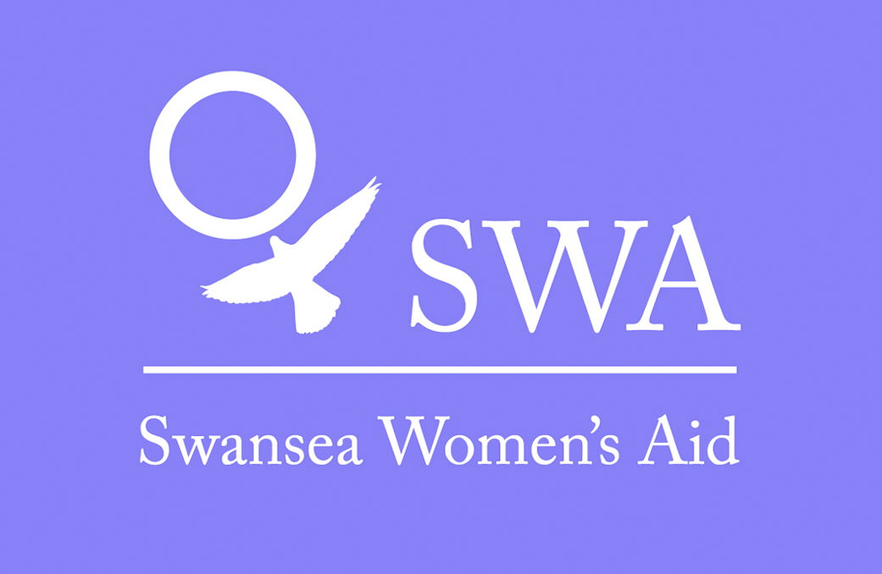

CHYPS PROJECT INFORMATION

The CHYPS project will work with children and young people aged 5 – 18 years who have experience of domestic abuse – past or present.

The staff team will consist of 3 Community Support Workers, a part time Play and Activities Worker, a part time Referral and Engagement Worker and the CHYPS Team Leader.

Forest School Project
The SWA Forest School Project will offer a bespoke service for children and young people aged 5-18 who have been affected by domestic abuse. In Year 1 the project was run in partnership with Forest School Swansea Neath Port Talbot, an organisation which provides sessions in woodland and coastal settings for children and young people with the aim of to raising self-esteem and self-confidence and appreciation of the natural environment. During Years 2 and 3, the worker will plan, prepare and deliver the Forest School Project programme of outdoor learning sessions, with support provided by volunteers.

Equal Opportunities Monitoring Form

In accordance with our equal opportunities policy, SWA will provide equality of opportunity to all employees and job applicants and will not discriminate either directly or indirectly on the grounds of race, sex, gender identity, marital status, disability, sexual orientation, pregnancy or maternity, religion/belief or age.

Your assistance is requested to allow us to monitor the effectiveness of our Equal Opportunities Policy by completing and returning this form. Please note that the monitoring form does not form part of your application and will be detached from it on receipt, stored separately in a locked confidential file and will not be available to the selection panel. You can send it separately if you wish.

On receipt an officer unconnected with the selection process will compile anonymous statistics from all applications. Personal information will not be shared and all forms will be destroyed after 3 months. The information you provide will not be used for any other purpose than to monitor the effectiveness of the equal opportunities policy, anonymous monitoring statistics only may be reviewed by the Board and or our funders.

Personal Details:
Please tick the boxes that are relevant to you and complete all sections

1.Age | 16-24 | 25-29 |  |  | 30-34 |  | 35-39 |  |  | 40-44
 | 45-49 | 50-54 |  |  | 55-59 |  | 60-64 |  |  | 65+
Prefer not to state Age
2. Gender | Male |  |  |  |  | Female
Prefer not to state gender
Gender Identity (options) | If you identify as transsexual, transgender (in that you have effected a permanent change of gender identity) or as intersex which group do you identify with?
Gender Identity (options) | Transsexual |  |  | Transgender |  |  |  |  | Intersex
3.Married/Civil partnership | Yes |  | No |  |  |  |  | Prefer not to say

4.Pregnancy and Maternity

I am pregnant/adopting a child Yes No Prefer not to say

5.Sexual Orientation: Please tick against one of the following

Bisexual |  | Gay Man
Gay Woman / Lesbian |  | Heterosexual / Straight
Other |  | Prefer not to say

6.Religion or belief: Please tick against one of the following

No religion |  | Buddhist |  | Christian
Hindu |  | Jewish |  | Muslim
Sikh |  | Prefer not to say
Other |  | Please state:

7.Ethnic origin: Please tick against one of the following

Asian/  Asian British; | Bangladeshi
Asian/  Asian British; | Chinese
Asian/  Asian British; | Indian
Asian/  Asian British; | Pakistani
Asian/  Asian British; | Other Asian
Black/African/Caribbean/  Black British; | African
Black/African/Caribbean/  Black British; | Caribbean
Black/African/Caribbean/  Black British; | Other Black
Mixed/  Multiple Ethnic Groups; | White & Asian
Mixed/  Multiple Ethnic Groups; | White & Black African
Mixed/  Multiple Ethnic Groups; | White & Black Caribbean
Mixed/  Multiple Ethnic Groups; | Other Mixed
Other Ethnic Group; | Arab
Other Ethnic Group; | Any Other Ethnic Group
White; | English/Welsh/Scottish/Northern Irish/British
White; | Gypsy or Irish Traveller
White; | Irish
White; | Other White
Prefer not to say | Other White

8.Disability: Please tick against one of the following

Disability definition under the Equality Act 2010
In the Act, a person has a disability if:
- they have a physical or mental impairment
- the impairment has a substantial and long-term adverse effect on their ability to perform normal day-to-day activities
- For the purposes of the Act, these words have the following meanings:
- 'substantial' means more than minor or trivial
- 'long-term' means that the effect of the impairment has lasted or is likely to last for at least twelve months (there are special rules covering recurring or fluctuating conditions)
- 'normal day-to-day activities' include everyday things like eating, washing, walking and going shopping
People who have had a disability in the past that meets this definition are also protected by the Act.

Progressive conditions considered to be a disability
There are additional provisions relating to people with progressive conditions. People with HIV, cancer or multiple sclerosis are protected by the Act from the point of diagnosis. People with some visual impairment are automatically deemed to be disabled.

Conditions that are specifically excluded
Some conditions are specifically excluded from being covered by the disability definition, such as a tendency to set fires or addictions to non–prescribed substances.

Do you consider yourself to have a disability according to the terms above? Yes/No/Prefer not to say
If you have answered yes, please indicate the type of impairment which applies to you. If your experience more than one type of impairment, please tick all the types that apply. If your disability does not fit any of these types, please circle Other and specify.
Physical/mobility impairment, such as a difficulty using your arms or mobility issues which require you to use a wheelchair or crutches
Visual impairment, such as being blind or having a serious visual impairment
Hearing impairment, such as being deaf or having a serious hearing impairment
Mental health condition, such as depression or schizophrenia
Learning disability/difficulty, such as Down’s syndrome or dyslexia or a cognitive impairment such as autistic spectrum disorder
Long-standing illness or health condition, such as cancer, HIV, diabetes, chronic heart disease or epilepsy

Other (Please specify below)

Yes No Prefer not to say

This information is provided for monitoring purposes only – if you need reasonable adjustments you should arrange these separately as this form will not be seen by the recruitment officers.

Thank you for taking the time to complete the information requested on this form, and thereby enabling us to monitor the effectiveness of our equal opportunities policy.

Name:

Signature: Date:

