SWANSEA WOMEN’S AID
APPLICATION PACK

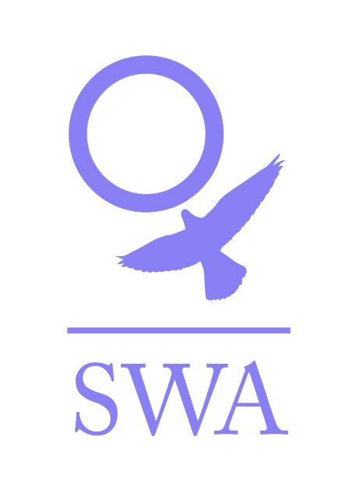

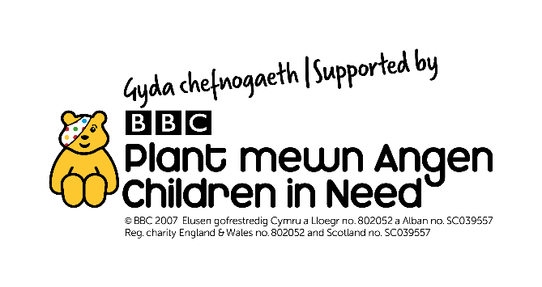

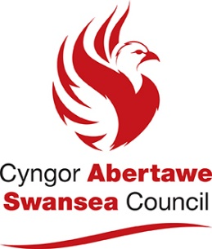

Dear Applicant,

Thank you for your interest in employment with Swansea Women’s Aid. You will find enclosed:

- Job Description and Person Specification
- Application form
- SWA vision, mission and values
- SWA philosophy
- Information sheet
- Project information
- Equal Opportunities Monitoring Form

Please ensure that you follow the guidelines when completing the application form. We operate an equal opportunities recruitment policy and use a pointing system for short-listing. If the application form is not completed as directed, this could mean that you will lose out on points.

Completed application forms can either be returned by post to Recruitment, Swansea Women’s Aid, 28 Bond St, Swansea, SA1 3TU or by email to swa@swanseawa.org.uk.

Additional information regarding Swansea Women’s Aid is available on www.swanseawomensaid.org. and you may find it useful to refer to this site when making your application.

The closing date for applications is 9am on Monday, 5th July 2021.
Please note that any applications received after this date/time will not be considered.

Interviews will take place on Friday 9th July 2021 via Zoom.

Should you require any further information regarding this post, please ring 01792 644683 and ask to speak to the Finance Manager, Elaine Howarth.

We wish you every success in your application.

Yours sincerely,

Lynne Sanders
Chief Executive

SWANSEA WOMEN’S AID

SWANSEA WOMEN’S AID

JOB DESCRIPTION

Job Title: Administration Worker – Central Services

Reports To: Finance Manager

Direct Reports: none

Main Purpose of the Role
To support the Central Services function of SWA by undertaking core administrative tasks on a day-to-day basis and providing administrative support to the wider organisation as and when required.

Specific Responsibilities:
      - Open, record, distribute and respond, as appropriate, to all incoming SWA mail including electronic mail
      - Frequent cover of SWA public phone line - answering the phone and directing phone calls to the relevant staff, booking DAISE appointments & sending out letters.
      - Liaise with staff re: clinical supervision appointments
      - Perform financial administrative tasks as directed by the Finance Manager e.g. preparing BACS input form, preparing cheques, paying in of banking, writing out cash requisition forms, reconciliation of petty cash and surcharges, filing, reconcile taxi invoices with database and support workers.
      - Development of forms, templates etc. as identified as needed to facilitate the financial administration of SWA.
      - To ensure the prompt payment of invoices following authorisation by the Finance Manager.
      - To administer and reconcile the rental records for SWA accommodation, highlighting any areas of concern with the Finance manager.
      - To deal with queries regarding payments, invoices etc. as directed by the Finance Manager.
      - Purchasing of stationery, printer ink, office supplies.
      - Undertake internet research in relation to purchases and purchase as directed by managers for all of the SWA projects.
      - Undertake internet research to assist projects and the Management team.
      - Admin for the arranging/booking of staff training, including contacting potential trainers, arranging venue, setting up training room, completion of booking forms, circulating details to staff etc.
      - Maintain and regularly review the training tracker for all SWA Staff, Volunteers and Trustees.
      - Maintenance of central filing systems.
      - Maintenance of central databases to ensure provision of statistical information, including UKROL and on call database.
      - Uploading of data onto the OASIS database as required in relation to relevant information recorded from any correspondence/phone calls received.
      - Undertake an audit of the literature and resources available within SWA and, after review, ensure that all the required resources are in place and catalogued.
      - Maintain appropriate levels of SWA publicity materials and assist in its distribution.
      - Maintain appropriate levels of sundries e.g. cleaning materials, PPE and assist in its distribution.
      - Update SWA noticeboards to ensure that all displayed information is up-to-date and clearly identifiable.
      - Photocopy paperwork, policies, forms etc. as needed to guarantee an appropriate supply for all staff and service users and as requested.
      - Liaison with photocopier suppliers if repairs, toner etc. is required.
      - Take minutes of Full Team Meetings and other meetings as directed by the CEO and Finance Manager.
      - Undertake ad hoc administrative tasks as directed.

General
- Demonstrate and promote the organisation’s ethos of informed choice, and its vision and values.
- Participate in team meetings, supervision and appropriate training
- Work in accordance with SWA Policies and Procedures and standards and overall aims and objectives of SWA.
- Undertake any other reasonable duties as required by the Finance Manager and/or the management team
- Proactively implement SWA policies for anti-discriminatory practice and equality of opportunity, ensuring that services are available for and meet the needs of all e.g. minority and disabled women etc.

Person Specification: (the skills, experience and qualities which are expected from Administration Workers)

Essential Characteristics

Personal and Administrative skills
- Good communication skills both written and verbal.
- Experience of administrative skills – e.g. filing systems, record keeping and databases.
- Experience in finance administration e.g. reconciliation and petty cash systems
- I.T skills – ability to use basic programmes such as Microsoft Office.
- Ability to work as part of a team and on own initiative.
- Good organisational skills – i.e. ability to prioritise.
- An awareness and commitment to the principle of empowerment and self-help.
- Ability to work within SWA refuge and central office at Bond Street, Swansea

Strongly Desirable

  - Ability to speak welsh or other language

Desirable

- SAGE software experience
- ECDL Level 2
- A full valid driving license and access to use of own car.
- Ability to undertake risk assessment with regards to yourself and co-workers.
- A commitment to Welsh Women’s Aid way of working.

Note to applicant: Admin roles are historically lengthy, as is this one. However, tasks will be prioritised and shared amongst the team therefore some of the above will only need completing periodically.

PRIVATE AND CONFIDENTIAL

SWANSEA WOMEN’S AID
APPLICATION FORM

POST: ADMINISTRATION WORKER

PERSONAL DETAILS

Name: ………………………………………….

Address:…………………………………………………………………………..

…………………………………………………………………………………...

…………………………………………………Post code: ……………………

Tel No: (Day)…………………………… (Eve)……………………………..

E Mail address:………………………………………………..
Please note if your daytime tel. no is your present employment: If we need to ring you in relation to this post, we will not disclose this.

Please give the name of two referees, one of whom must be your recent/previous employer. Please note that references will only be taken up when an offer of employment is made

Name………………………………….. Name………………………………………

Position……………………………….. Position……………………………………

Address……………………………….. Address……………………………………

………………………………………... …………………………………………….

……………………………………….. …………………………………………….

Postcode……………………………… Postcode…………………………………..
Email: Email:

Successful appointment is subject to satisfactory references and an enhanced Disclosure and Barring Service Check (DBS)

Under the Equality Act 2010 pursuant to Schedule 9, Part 1, this is a women only post

Question 1

EMPLOYMENT HISTORY
As an organisation, SWA attaches equal value to experience gained through both paid and voluntary employment.
DATES  FROM TO | EMPLOYER’S NAME & ADDRESS | POSITION HELD & DUTIES | SALARY & REASON FOR LEAVING

Question 2
SWA is interested in any formal or informal qualifications that you may have, particularly those relevant to this post. Please also include details of any relevant training undertaken.

QUALIFICATIONS
DATES  FROM TO | SCHOOL,COLLEGE, UNIVERSITY ETC | QUALIFICATION &/OR COURSE NAME
TRAINING COURSES/SEMINARS ATTENDED
DATE ATTENDED | ORGANISING BODY | DETAILS OF COURSE/SEMINAR including any certification awarded

Question 3
With reference to the Person Specification for the post, please explain and provide examples of how you meet each essential and desirable criterion (please ensure you follow the guidelines relating to question 3 on the ‘filling in the form guidelines’ page below). Please attach a continuation sheet if necessary.
Question 4
Please give brief details of your personal interests and hobbies, particularly where they illustrate the use of skills and personal qualities relevant to the post.

Question 5
COMPUTER LITERACY
Do you have any experience of using work processors/computers?

YES / NO

If YES, please give details of software packages used:

Question 6
Please tell us of any dates when you would not be available for interview: ……………………

DECLARATION
I certify that all the information provided in this application form is true, accurate and complete to the best of my knowledge and that I have the right to work in the United Kingdom. I understand that should this not be the case, then it may put any offer of employment made by SWA in jeopardy, or result in dismissal.

SIGNED: …………………………… DATED: ……………………

ON COMPLETION, PLEASE RETURN THIS APPLICATION FORM, MARKED PRIVATE AND CONFIDENTIAL TO:

Recruitment
Swansea Women’s Aid
28 Bond St
Swansea,
SA1 3TU

OR

By email to swa@swanseawa.org.uk

Applications must reach us by the closing date for this post: 9am on Monday, 5th july 2021.

Data Protection/GDPR
You will either have sent your personal data directly to us or to a third party agency. However, your application is sent, it will be received by an authorised administrator who will separate the application form from the Equal Opportunity form, log that your application has been received and pass your application form to the Recruitment Officer. The Administrator plays no role in the selection process but will be given your contact details to advise you of the progress of your application, as advised by the Office Manager.

All information held about you is treated as confidential, protected by passwords /locked files, as appropriate and access strictly restricted to nominated persons and will be deleted, as soon as possible and within 6 months of completion of the recruitment process.

The Administrator collates and anonymises the equal opportunities monitoring data to provide general statistics relating to SWA’s equal opportunities performance, which may be reviewed by the Management Team, Board and or funders. It will not be used for any other purpose.

The data on your application form will only be viewed by the Recruitment Officers and used for selection purposes only. It will not be passed on to any other person/third party or used for any other person.

Only the successful candidate’s application will be retained and it will be retained for the duration of employment to be destroyed 6 months after the individual has left the organisation.

We take our responsibility to protect your personal data seriously and if you have any queries or concerns or wish to amend any of the information provided, you can raise these to the appropriate person. Please see www.swanseawomensaid.com for SWA’s Privacy Policy.

Please indicate below where you saw the job advertisement for this post:

………………………………………………………………………………………………..
E.g. Job Centre, Charity Job Finder, Recruit 3, SWA website etc

Filling in the form guidelines

If you have a communication difficulty such as dyslexia, please make us aware of this.

Pointing system

In order to reach the shortlist, an applicant must meet ALL of the essential criteria in the Person Specification. Each essential criterion carries points of 0 to 3. Each desirable criterion carries points of 0 to 1. If an applicant points zero on any of the essential criteria, they will not be considered for the shortlist, even if the applicant pointed highly elsewhere. Applicants who are short-listed generally point between 2 & 3 on each essential criterion. Applicants do not need to score on the desirable criteria to be short- listed.

To score between 2 & 3, an applicant must outline their experience / ability and then demonstrate.

For example, a question in the application form asks about applicant’s organisational skills. An applicant may state that in all their jobs they have been required to have good organisational skills (Outlining experience). Demonstrate this by telling us how you developed them, for example, ‘through work where I was required to…’ or, ‘through training / voluntary work / education, it was essential to…’

It is essential when answering Question 3 that you ensure that you address each of the essential criteria. The easiest way to ensure this is to use the headings and numberings on the Person Specification as follows:

Support Skills
- 1.Experience of working with women (and children) with differing social and emotional needs.
Answer

- An awareness and an understanding of the differing experiences of different cultural and social backgrounds.
Answer

- An understanding/experience of the causes and the long term effects of domestic abuse.
Answer

This advice may seem a bit basic but it is surprising how often applicants can focus on certain essential criteria and fall short on others. We want all applicants to have the best possible opportunity to highlight the required experience and skills to work effectively within this post.

SWANSEA WOMEN’S AID

Vision
A world where women and children are free from abuse

Mission statement
To provide innovative and sustainable high quality domestic abuse services that aid prevention, address women’s and children’s needs and enable them to move forward positively

Values

- Excellence – in all we do and how we do it

- Equality –non-discriminatory and non-judgemental

- Diversity – everyone welcomed and valued

- Women and children at the heart of all we do – being supported, informing and directing services

- Innovation – in service delivery and planning

- Integrity - honesty, reliability, trustworthiness

- Empowerment – encouraging women and children to reach their full potential

- Confidential – respecting privacy and lawful

- Collaborative – working with others to change things for the better

SWANSEA WOMEN’S AID - PHILOSOPHY

Women only
Swansea Women’s Aid is part of the wider Women’s Aid movement, run by women for women. We believe that in order to develop confidence and self-esteem, women need ‘space’ to identify their strength and weaknesses away from male influence. Sexism serves not only to systematically undermine and abuse women but also to divide women and alienate them from each other. We feel that the ‘space’ that Women’s Aid provides for women allows them to define themselves according to their own needs and not according to the attitudes of society.

Admissions
Refuge and Safe House space is there for all women who are experiencing domestic violence and are afraid to live in their own homes. We do not discriminate against any woman on grounds of race, religion, sexual orientation or disability. If our Refuge or Safe Houses in Swansea are full, we will contact other groups throughout Wales until Refuge space is found.

Self Help
It is essential to our work to provide a place of safety where women can determine their own future. Women staying in the Refuge are responsible for the day to day running of the house. We believe that it is crucial that women are given the space to rebuild their confidence so that they can resume responsibility for their lives in an atmosphere of mutual respect and co-operation. Women’s Aid supports women in this development at whatever stage individual women are at any time.

SWANSEA WOMEN’S AID
INFORMATION SHEET

JOB TITLE: ADMINISTRATION WORKER

HOURS OF WORK: 28 PER WEEK. Hours are agreed and need to be worked flexibly. The post holder will work 4 days per week and be flexible to cover 5 days if and when needed (e.g. to cover holidays).

SALARY: £17,290 per annum, pro rata

CONTRACT LENGTH: This is a permanent post subject to funding.

HOLIDAY ENTITLEMENT: 25 days per year, pro rata, plus 9 bank holidays.

PROBATIONARY PERIOD: Six months

PENSION: Swansea Women’s Aid contributes 6% of the basic annual salary into the Swansea Women’s Aid qualifying workplace pension scheme.

OTHER:

All workers are required to undergo an enhanced DBS check.

The post holder will work within the Central Services Team and will report to the Finance Manager.

Swansea Women’s Aid is a women-only organisation with both paid and unpaid workers and is affiliated to Welsh Women’s Aid.

Swansea Women’s Aid is an equal opportunities employer and welcomes applications from all sectors of the community.

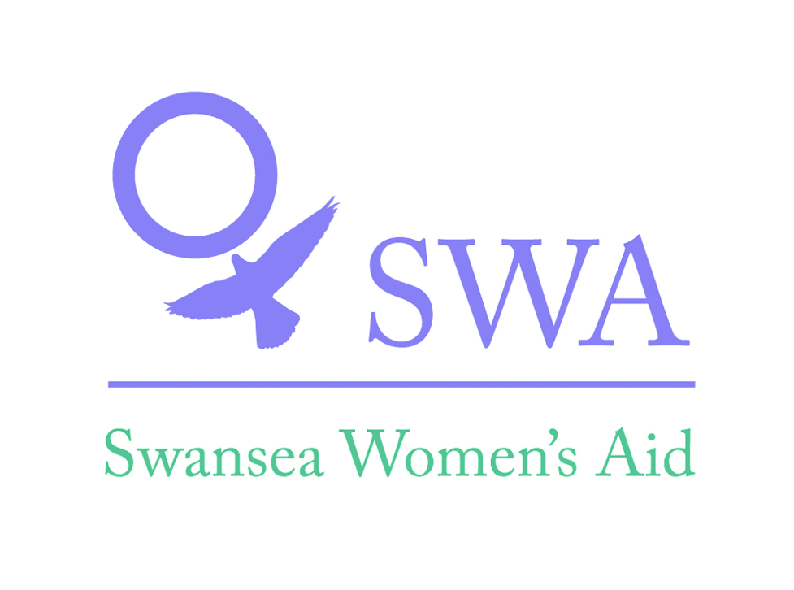

About Swansea Women’s Aid
Swansea Women’s Aid is a women-only organisation which supports women, with or without children, who are affected by domestic abuse.

What is Domestic Abuse?
Women’s Aid defines domestic abuse as the misuse of power and control by one individual over another within a close relationship. Although the majority of abuse is directed by men against women, it can and does occur in lesbian relationships. The perpetrators of domestic abuse are not limited to a woman’s partner or ex-partner; it can include brothers, fathers, cousins, uncles, mothers, sisters, in-laws etc…
Swansea Women’s Aid workers have specialist knowledge on issues related to domestic abuse and how it can affect the lives of women and children.

Prevention and education
As a specialist domestic abuse agency, Swansea Women’s Aid is able to design and deliver bespoke training packages to meet the needs of organisations.
We welcome all opportunities to raise awareness of domestic abuse and can deliver talks and presentations to community and social groups adapted to suit the audience.

SWA
Equal Opportunities Monitoring Form

SWA recognises and actively promotes the benefits of a diverse workforce and is committed to treating all employees with dignity and respect.

In accordance with our equal opportunities policy, SWA will provide equality of opportunity to all employees and job applicants and will not discriminate either directly or indirectly on the grounds of race, sex, gender identity, marital status, disability, sexual orientation, pregnancy or maternity, religion/belief or age.

We have only asked for your name so that monitoring can take place at short listing and appointment stages. The monitoring form does not form part of your application and will therefore be detached from it on receipt, stored separately and will not be available to the selection panel. You can send it separately if you wish.

Personal Details:
Please complete all sections

Age | 16-24 | 25-29 |  |  | 30-34 |  | 35-39 |  |  | 40-44
 | 45-49 | 50-54 |  |  | 55-59 |  | 60-64 |  |  | 65+
Gender | Male |  |  |  |  | Female
Gender Identity (options) | If you identify as transsexual, transgender (in that you have effected a permanent change of gender identity) or as intersex which group do you identify with?
 | Transsexual |  |  | Transgender |  |  |  |  | Intersex
Married/Civil partnership | Yes |  | No |  |  |  |  | Prefer not to say

Pregnancy and Maternity
I am pregnant/adopting a child Yes No Prefer not to say

Sexual Orientation: Please tick against one of the following

Bisexual |  | Gay Man
Gay Woman / Lesbian |  | Heterosexual / Straight
Other |  | Prefer not to say

Religion or belief: Please tick against one of the following

No religion |  | Buddhist |  | Christian
Hindu |  | Jewish |  | Muslim
Sikh |  | Prefer not to say
Other |  | Please state:

Ethnic origin: Please tick against one of the following

Asian/  Asian British; | Bangladeshi
 | Chinese
 | Indian
 | Pakistani
 | Other Asian
Black/African/Caribbean/  Black British; | African
 | Caribbean
 | Other Black
Mixed/  Multiple Ethnic Groups; | White & Asian
 | White & Black African
 | White & Black Caribbean
 | Other Mixed
Other Ethnic Group; | Arab
 | Any Other Ethnic Group
White; | English/Welsh/Scottish/Northern Irish/British
 | Gypsy or Irish Traveller
 | Irish
 | Other White
Prefer not to say

Disability: Please tick against one of the following

Disability definition under the Equality Act 2010
In the Act, a person has a disability if:
- they have a physical or mental impairment
- the impairment has a substantial and long-term adverse effect on their ability to perform normal day-to-day activities
- For the purposes of the Act, these words have the following meanings:
- 'substantial' means more than minor or trivial
- 'long-term' means that the effect of the impairment has lasted or is likely to last for at least twelve months (there are special rules covering recurring or fluctuating conditions)
- 'normal day-to-day activities' include everyday things like eating, washing, walking and going shopping
People who have had a disability in the past that meets this definition are also protected by the Act.

Progressive conditions considered to be a disability
There are additional provisions relating to people with progressive conditions. People with HIV, cancer or multiple sclerosis are protected by the Act from the point of diagnosis. People with some visual impairment are automatically deemed to be disabled.

Conditions that are specifically excluded
Some conditions are specifically excluded from being covered by the disability definition, such as a tendency to set fires or addictions to non–prescribed substances.

Do you consider yourself to have a disability according to the terms above? Yes/No/Prefer not to say
If you have answered yes, please indicate the type of impairment which applies to you. If your experience more than one type of impairment, please tick all the types that apply. If your disability does not fit any of these types, please circle Other and specify.
Physical/mobility impairment, such as a difficulty using your arms or mobility issues which require you to use a wheelchair or crutches
Visual impairment, such as being blind or having a serious visual impairment
Hearing impairment, such as being deaf or having a serious hearing impairment
Mental health condition, such as depression or schizophrenia
Learning disability/difficulty, such as Down’s syndrome or dyslexia or a cognitive impairment such as autistic spectrum disorder
Long-standing illness or health condition, such as cancer, HIV, diabetes, chronic heart disease or epilepsy
Other (Please specify below)

Yes No Prefer not to say

This information is provided for monitoring purposes only – if you need reasonable adjustments you should arrange these separately.

Thank you for taking the time to complete the information requested on this form, and thereby enabling us to monitor the effectiveness of our equal opportunities policy.
Name:
Signature: Date:

