SWANSEA WOMEN’S AID
APPLICATION PACK

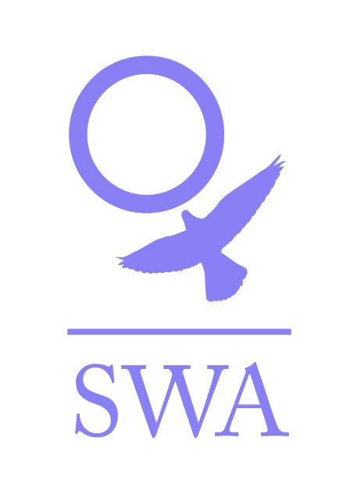

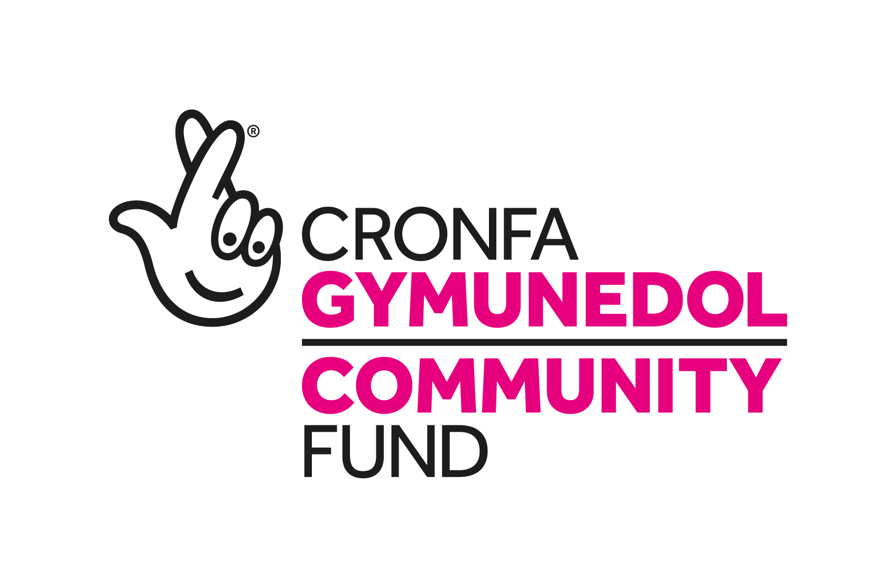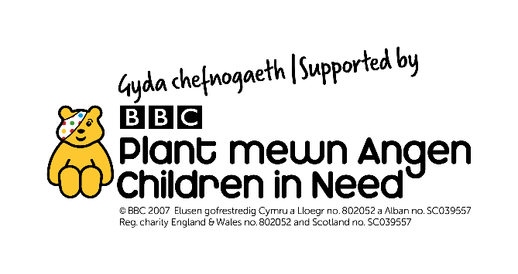

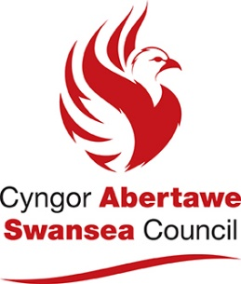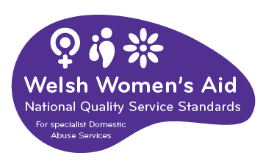

Dear Applicant,

Thank you for your interest in employment with Swansea Women’s Aid. You will find enclosed:

- Job Description and Person Specification
- Application form
- SWA vision, mission and values
- SWA philosophy
- Information sheet
- Project information
- Equal Opportunities Monitoring Form

Please ensure that you follow the guidelines when completing the application form. We operate an equal opportunities recruitment policy and use a pointing system for short-listing. If the application form is not completed as directed, this could mean that you will lose out on points.

Completed application forms can either be returned by post to Recruitment, Swansea Women’s Aid, 28 Bond St, Swansea, SA1 3TU or by email to swa@swanseawa.org.uk.

Additional information regarding Swansea Women’s Aid is available on www.swanseawomensaid.org. and you may find it useful to refer to this site when making your application.

The closing date for applications is 9am on Monday, 5th July 2021.
Please note that any applications received after this will not be considered.

Interviews will take place on Thursday, 8th July, 2021 via Zoom.

Start date is Monday 12th July 2021.

Should you require any further information regarding this post, please ring 01792 644683 and ask to speak to the DAISE Team Leader, Becky Frohwien.

We wish you every success in your application.

Yours sincerely,

Lynne Sanders
Chief Executive

SWANSEA WOMEN’S AID
JOB DESCRIPTION

Job Title: DAISE Plus Project Support Worker

Reports To: DAISE Plus Project Team Leader

Direct Reports : None

Main Purposes of the Role
- To support development and delivery of the Domestic Abuse Information, Support end Empowerment (DAISE) project, responding to the emotional and practical needs of women and children accessing SWA projects, working within the SWA framework.
- To assist and facilitate women using the service to make informed decisions and positive changes to their lives, to minimise risk of homelessness and enhance their future.
- To use the self-help principle to encourage independence and empower the service user to succeed on all levels.

Core SW Responsibilities:

- Admit new service users onto SWA projects and complete relevant project paperwork e.g. licence agreement, referral form, needs assessments etc.
- Develop support plans in line with needs assessments for approval by Team Leader, action the approved plans and review accordingly.
- Provide an appropriate level of support to the women in line with support plans, ensuring that all options are systematically appraised and making use of a wide range of development opportunities (e.g. training and employment).
- Act as an advocate on behalf of service user encouraging and supporting self-advocacy as appropriate.
- Support service users through the process of re-housing if/when required. Liaising and networking with appropriate agencies, support women to settle in the community, providing information on amenities etc.
- Assist service users to apply for/maintain/maximise benefits and income and manage other financial issues, making appropriate referrals where necessary.
- Assist and support service users to access health services, legal services, housing etc. according to identified need.
- Work with SWA staff in other projects and services to ensure the smooth running of all SWA projects and a seamless service is provided for women accessing them.
- Comply with all SWA policies and procedures at all times, paying particular regard to SWA’s child and adult protection/procedures and health and safety policies and procedures, taking steps to remove immediate risks and reporting any risks/concerns/issues to the appropriate person (e.g. Team Leader/ Supported Housing Coordinators) in line with SWA policy.
- Encourage and enable service user participation in the development of all areas of service provision, including organisational and project specific consultation processes, policy review, service review and development etc.
- Provide and facilitate 1:1 support and group activities for women using the principle of self-help to promote and encourage independence and empowerment.
- Establish and maintain accurate and up to date records of all support sessions, telephone conversations, attendance and appointments etc, including progress made on behalf of women and children. Assist the Team Leader in related project administration tasks to include keeping accurate records of e.g. repairs, contacts, referrals, finance, statistical information, outcomes data etc, as required.
- Direct and assist volunteers as appropriate.
- Provide occasional cover for support staff in other projects/services when required and to the extent that training and skills allow.

Service/project specific SW responsibilities:

- Participate in the development and provision of remotely based support surgeries, developing and maintaining positive relationships with key staff, volunteers and community members to maximize the reach, benefit and quality of the service(s) provided.
- Deliver the Freedom Programme and Recovery Toolkit sessions at SWA, Swansea One Stop Shop and in other venues as required.
- Contribute positively to the development and smooth running of the new One Stop Shop by working with key personnel to ensure consistent cover and provision of the DAISE service.
- Work with other local specialist agencies who provide support with issues which often overlap with domestic abuse (eg substance misuse, mental health) to provide the DAISE service in a way which meets their specific needs.
- Use delivery experience gained throughout the project to contribute to the ongoing monitoring, evaluation and project management processes, for DAISE and other services if appropriate, suggesting development opportunities where appropriate.

General
- Demonstrate and promote the organisation’s ethos of informed choice and its vision and values at all times.
- Represent the organisation at external meetings, public events, conferences and similar ensuring that SWA’s reputation is protected and enhanced.
- Keep up to date with changes in legislation that will affect women and children who are or have experienced domestic abuse.
- Actively work in partnership with other agencies and organisations to achieve better outcomes for women and children affected by Domestic Abuse.
- Participate in team meetings, supervision and appropriate training
- Work in accordance with the Welsh Women’s Aid Codes of Practice, SWA Policies and Procedures and standards and overall aims and objectives of SWA.
- Contribute to the development and review of SWA policies and procedures.
- Proactively implement SWA policies for anti-discriminatory practice and equality of opportunity, ensuring that services are available for and meet the needs of all e.g. minority and disabled women etc.
- The post holder will be required to work evenings and weekends on a regular basis and to participate in the organisation’s 24-hour on call rota.
- Any other reasonable duties as required by the Team Leader.

N.B
The above job description will be reviewed and may change as necessary with prior consultation.

The post holder should regard this job description with a degree of flexibility as the range of duties is not exhaustive and may also change to meet the needs of SWA or the project.

PERSON SPECIFICATION

Job Title: DAISE Plus Support Worker

Reports To: DAISE Plus Team Leader

Direct Reports : None

Essential Characteristics

Support Skills
- Experience of working with women (and children) with differing social and emotional needs.
- An awareness and an understanding of the differing experiences of women from different cultural and social backgrounds.
- An understanding/experience of the causes and the long term effects of domestic abuse.
- Experience of support planning and review and managing a caseload.
- A clear understanding of boundaries within support work.
- An understanding of the issues around service user participation and how to engage them in productive and meaningful dialogue.
- Ability to liaise, network and advocate.
- Experience of managing challenging behaviour and conflict
- Experience of working in a crisis environment.
- Experience of group work.
- Have or be willing to work towards a qualification in the provision of Information, Advice and Guidance.

Personal and Administrative skills
- Good communication skills both written and verbal.
- Experience of administrative skills-i.e. filing systems, record keeping, databases and petty cash systems.
- I.T skills – ability to use basic programmes.
- Ability to work as part of a team and on own initiative.
- Good organisational skills – i.e. ability to prioritise.
- Ability to undertake risk assessment with regards to yourself, co-workers and service users.
- A commitment to Swansea Women’s Aid way of working.
- An awareness and commitment to the principle of empowerment and self-help.
- Ability to work evenings and weekends as required and to participate in the organisation’s 24 hour on-call rotas.

Strongly Desirable

  - The ability to speak Welsh

Desirable

- A full valid driving licence.
- Ability to speak another language.
- Good understanding, experience or qualification in the following.
- Mental Health
- Drug/Alcohol
- Housing
- Immigration
- Counselling
- Complimentary Therapies
- Child Development
- Community development

PRIVATE AND CONFIDENTIAL

SWANSEA WOMEN’S AID
APPLICATION FORM

POST: DAISE PLUS SUPPORT WORKER

PERSONAL DETAILS

Name: ………………………………………….

Address:…………………………………………………………………………..

…………………………………………………………………………………...

…………………………………………………Post code: ……………………

Tel No: (Day)…………………………… (Eve)……………………………..

E Mail address:………………………………………………..
Please note if your daytime tel. no is your present employment: If we need to ring you in relation to this post, we will not disclose this.

Please give the name of two referees, one of whom must be your recent/previous employer. Please note that references will only be taken up when an offer of employment is made

Name………………………………….. Name………………………………………

Position……………………………….. Position……………………………………

Address……………………………….. Address……………………………………

………………………………………... …………………………………………….

……………………………………….. …………………………………………….

Postcode……………………………… Postcode…………………………………..
Email: Email:

Successful appointment is subject to satisfactory references and an enhanced Disclosure and Barring Service Check (DBS)

Under the Equality Act 2010 pursuant to Schedule 9, Part 1, this is a women only post

Question 1

EMPLOYMENT HISTORY
As an organisation, SWA attaches equal value to experience gained through both paid and voluntary employment.
DATES  FROM TO | EMPLOYER’S NAME & ADDRESS | POSITION HELD & DUTIES | SALARY & REASON FOR LEAVING

Question 2
SWA is interested in any formal or informal qualifications that you may have, particularly those relevant to this post. Please also include details of any relevant training undertaken.

QUALIFICATIONS
DATES  FROM TO | SCHOOL,COLLEGE, UNIVERSITY ETC | QUALIFICATION &/OR COURSE NAME
TRAINING COURSES/SEMINARS ATTENDED
DATE ATTENDED | ORGANISING BODY | DETAILS OF COURSE/SEMINAR including any certification awarded

Question 3
With reference to the Person Specification for the post, please explain and provide examples of how you meet each essential and desirable criterion (please ensure you follow the guidelines relating to question 3 on the ‘filling in the form guidelines’ page below). Please attach a continuation sheet if necessary.
Question 4
Please give brief details of your personal interests and hobbies, particularly where they illustrate the use of skills and personal qualities relevant to the post.

Question 5
COMPUTER LITERACY
Do you have any experience of using work processors/computers?

YES / NO

If YES, please give details of software packages used:

Question 6
Please tell us of any dates when you would not be available for interview: ……………………

DECLARATION
I certify that all the information provided in this application form is true, accurate and complete to the best of my knowledge and that I have the right to work in the United Kingdom. I understand that should this not be the case, then it may put any offer of employment made by SWA in jeopardy, or result in dismissal.

SIGNED: …………………………… DATED: ……………………

ON COMPLETION, PLEASE RETURN THIS APPLICATION FORM, MARKED PRIVATE AND CONFIDENTIAL TO:

Recruitment,
Swansea Women’s Aid.
28 Bond St,
Swansea,
SA1 3TU.

OR

By email to swa@swanseawa.org.uk

Applications must reach us by the closing date for this post: 9am on Monday, 5th July 2021.

Data Protection/GDPR
You will either have sent your personal data directly to us or to a third party agency. However, your application is sent, it will be received by an authorised administrator who will separate the application form from the Equal Opportunity form, log that your application has been received and pass your application form to the Recruitment Officer. The Administrator plays no role in the selection process but will be given your contact details to advise you of the progress of your application, as advised by the Recruitment Officer.

All information held about you is treated as confidential, protected by passwords /locked files, as appropriate and access strictly restricted to nominated persons and will be deleted, as soon as possible and within 6 months of completion of the recruitment process.

The Administrator collates and anonymises the equal opportunities monitoring data to provide general statistics relating to SWA’s equal opportunities performance, which may be reviewed by the Senior Team, Board and or funders. It will not be used for any other purpose.

The data on your application form will only be viewed by the Recruitment Officers and used for selection purposes only. It will not be passed on to any other person/third party or used for any other person.

Only the successful candidate’s application will be retained and it will be retained for the duration of employment to be destroyed 6 months after the individual has left the organisation.

We take our responsibility to protect your personal data seriously and if you have any queries or concerns or wish to amend any of the information provided, you can raise these to the appropriate person. Please see www.swanseawomensaid.com for SWA’s Privacy Policy.

Please indicate below where you saw the job advertisement for this post:

………………………………………………………………………………………………..
E.g. Job Centre, Charity Job Finder, Recruit 3, SWA website etc

Filling in the form guidelines

If you have a communication difficulty such as dyslexia, please make us aware of this.

Pointing system

In order to reach the shortlist, an applicant must meet ALL of the essential criteria in the Person Specification. Each essential criterion carries points of 0 to 3. Each desirable criterion carries points of 0 to 1. If an applicant points zero on any of the essential criteria, they will not be considered for the shortlist, even if the applicant pointed highly elsewhere. Applicants who are short-listed generally point between 2 & 3 on each essential criterion. Applicants do not need to score on the desirable criteria to be short- listed.

To score between 2 & 3, an applicant must outline their experience / ability and then demonstrate.

For example, a question in the application form asks about applicant’s organisational skills. An applicant may state that in all their jobs they have been required to have good organisational skills (Outlining experience). Demonstrate this by telling us how you developed them, for example, ‘through work where I was required to…’ or, ‘through training / voluntary work / education, it was essential to…’

It is essential when answering Question 3 that you ensure that you address each of the essential criteria. The easiest way to ensure this is to use the headings and numberings on the Person Specification as follows:

Support Skills
- 1.Experience of working with women (and children) with differing social and emotional needs.
Answer

- An awareness and an understanding of the differing experiences of different cultural and social backgrounds.
Answer

- An understanding/experience of the causes and the long term effects of domestic abuse.
Answer

This advice may seem a bit basic but it is surprising how often applicants can focus on certain essential criteria and fall short on others. We want all applicants to have the best possible opportunity to highlight the required experience and skills to work effectively within this post.

SWANSEA WOMEN’S AID

Vision
A world where women and children are free from abuse

Mission statement
To provide innovative and sustainable high quality domestic abuse services that aid prevention, address women’s and children’s needs and enable them to move forward positively

Values

- Excellence – in all we do and how we do it

- Equality –non-discriminatory and non-judgemental

- Diversity – everyone welcomed and valued

- Women and children at the heart of all we do – being supported, informing and directing services

- Innovation – in service delivery and planning

- Integrity - honesty, reliability, trustworthiness

- Empowerment – encouraging women and children to reach their full potential

- Confidential – respecting privacy and lawful

- Collaborative – working with others to change things for the better

SWANSEA WOMEN’S AID - PHILOSOPHY

Women only
Swansea Women’s Aid is part of the wider Women’s Aid movement, run by women for women. We believe that in order to develop confidence and self-esteem, women need ‘space’ to identify their strength and weaknesses away from male influence. Sexism serves not only to systematically undermine and abuse women but also to divide women and alienate them from each other. We feel that the ‘space’ that Women’s Aid provides for women allows them to define themselves according to their own needs and not according to the attitudes of society.

Admissions
Refuge and Safe House space is there for all women who are experiencing domestic violence and are afraid to live in their own homes. We do not discriminate against any woman on grounds of race, religion, sexual orientation or disability. If our Refuge or Safe Houses in Swansea are full, we will contact other groups throughout Wales until Refuge space is found.

Self Help
It is essential to our work to provide a place of safety where women can determine their own future. Women staying in the Refuge are responsible for the day to day running of the house. We believe that it is crucial that women are given the space to rebuild their confidence so that they can resume responsibility for their lives in an atmosphere of mutual respect and co-operation. Women’s Aid supports women in this development at whatever stage individual women are at any time.

SWANSEA WOMEN’S AID
INFORMATION SHEET

JOB TITLE: DAISE PLUS SUPPORT WORKER

HOURS OF WORK: 28 PER WEEK. Hours are agreed and need to be worked flexibly. The demands of the service may require you to work evenings and weekends. Any overtime will be compensated for by time in lieu.

SALARY: £21,029 per annum, pro rata

CONTRACT LENGTH: This is a temporary post, funded by the National Lottery through the Community Fund and will end 31st October 2021 (continuation funding is being sought).

HOLIDAY ENTITLEMENT: 25 days per year, plus 9 bank holidays (pro rata).

PROBATIONARY PERIOD: Three months

PENSION: Swansea Women’s Aid contributes 6% of the basic annual salary into the Swansea Women’s Aid qualifying workplace pension scheme.

OTHER:

All workers are required to undergo an enhanced DBS check.

The post holder will work within the Outreach Services team and will report to the DAISE Team Leader. The team supports families within the community.

The post holder will participate in the 24-hour on call rota on evenings and weekends. This will include out-of-hours admissions into the refuge and safe houses and call outs to deal with housing management issues. For a 35-hour post, the requirement is to cover 7 weekends, 26 week nights and 1 bank holiday per annum.

Swansea Women’s Aid is a women-only organisation with both paid and unpaid workers and is affiliated to Welsh Women’s Aid.

Swansea Women’s Aid is an equal opportunities employer and welcomes applications from all sectors of the community.

We particularly welcome applications from Welsh speaking candidates.

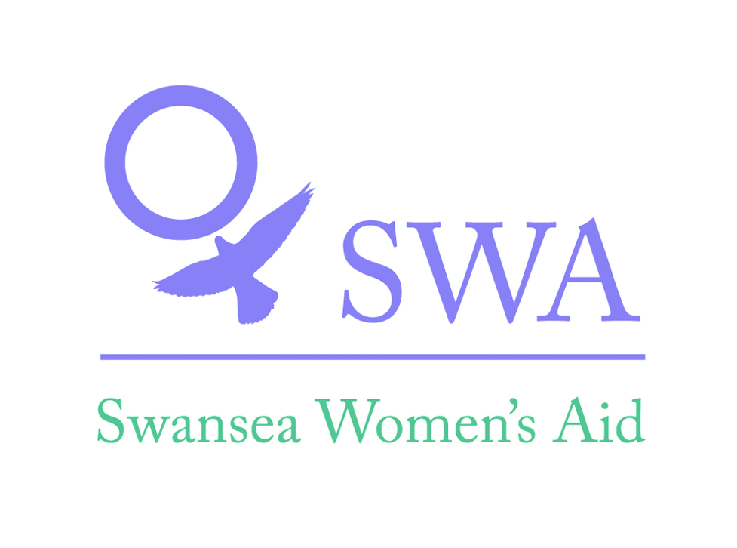DAISE Project Information
(DAISE - Domestic Abuse Information, Support and Empowerment)

Swansea Women’s Aid (SWA) DAISE Project supports women, with or without children, who are or have previously experienced domestic abuse. The SWA DAISE workers have specialist knowledge of issues relating to domestic abuse and how it can affect the lives of women and children. SWA DAISE workers are able to provide confidential emotional and/or practical support on an ad hoc basis or several times. Women can access the DAISE project through self-referral or referral by an external agency via our helpline (01792 644683).

What to expect from the DAISE Project:

- We will provide women with a safe environment to meet with a support worker and maintain confidentiality.
- We will respect and safeguard women’s rights and help them to be independent and have maximum control over their life.
- We will provide women with the support and information they need to make informed decisions about their safety and wellbeing.
- We will work alongside women to identify their key areas of need and set realistic objectives.
- We will provide sign-posting and referral to other projects/organisations where appropriate with consent.
- We will provide access to supplementary services such as The Freedom Programme, The Recovery Toolkit, Counselling, Homeopathy and Massage/Reflexology Therapy (subject to availability and waiting list).

Appointments:

Appointments are held at the SWA central office, the Swansea’s Domestic Abuse One Stop Shop and within community settings.
- Each session lasts approximately 45 minutes.
- Initially 6 sessions are offered however this may be extended to a maximum of 12 in certain circumstances.

Drop-In Service:

We recognise that women may need to be seen in a crisis and therefore cannot wait for a set appointment. This is why we offer a weekly drop-in service so that women can be seen the same week. We currently hold two drop-ins a week where woman can be seen for a maximum of 30 minutes and follow up appointments are offered to ensure women’s support needs are met.
Freedom Programme & Recovery Toolkit Programme:

The DAISE project currently runs two programmes that focus on raising awareness of domestic abuse and women’s experiences, delivered through group work facilitated by DAISE workers. Women are invited to meet in a confidential group to explore their experiences and learn about the different tactics of power and control used in an abusive relationship. Women are given resources to rebuild their confidence and strategies for coping and recovering from the harmful effects of domestic abuse.

Home Visits and Telephone Support:
SWA recognises that some women may have certain issues that prevent them for accessing the service. A home visit can be offered to women with a disability, severe mental health issue or childcare issue that prevent them from being able to leave their home. The DAISE project can also arrange telephone support should a home visit not be possible and will work to address any barriers that prevent women from accessing the service.

SWA
Equal Opportunities Monitoring Form

SWA recognises and actively promotes the benefits of a diverse workforce and is committed to treating all employees with dignity and respect.

In accordance with our equal opportunities policy, SWA will provide equality of opportunity to all employees and job applicants and will not discriminate either directly or indirectly on the grounds of race, sex, gender identity, marital status, disability, sexual orientation, pregnancy or maternity, religion/belief or age.

We have only asked for your name so that monitoring can take place at short listing and appointment stages. The monitoring form does not form part of your application and will therefore be detached from it on receipt, stored separately and will not be available to the selection panel. You can send it separately if you wish.

Personal Details:
Please complete all sections

Age | 16-24 | 25-29 |  |  | 30-34 |  | 35-39 |  |  | 40-44
 | 45-49 | 50-54 |  |  | 55-59 |  | 60-64 |  |  | 65+
Gender | Male |  |  |  |  | Female
Gender Identity (options) | If you identify as transsexual, transgender (in that you have effected a permanent change of gender identity) or as intersex which group do you identify with?
 | Transsexual |  |  | Transgender |  |  |  |  | Intersex
Married/Civil partnership | Yes |  | No |  |  |  |  | Prefer not to say

Pregnancy and Maternity
I am pregnant/adopting a child Yes No Prefer not to say

Sexual Orientation: Please tick against one of the following

Bisexual |  | Gay Man
Gay Woman / Lesbian |  | Heterosexual / Straight
Other |  | Prefer not to say

Religion or belief: Please tick against one of the following

No religion |  | Buddhist |  | Christian
Hindu |  | Jewish |  | Muslim
Sikh |  | Prefer not to say
Other |  | Please state:

Ethnic origin: Please tick against one of the following

Asian/  Asian British; | Bangladeshi
 | Chinese
 | Indian
 | Pakistani
 | Other Asian
Black/African/Caribbean/  Black British; | African
 | Caribbean
 | Other Black
Mixed/  Multiple Ethnic Groups; | White & Asian
 | White & Black African
 | White & Black Caribbean
 | Other Mixed
Other Ethnic Group; | Arab
 | Any Other Ethnic Group
White; | English/Welsh/Scottish/Northern Irish/British
 | Gypsy or Irish Traveller
 | Irish
 | Other White
Prefer not to say

Disability: Please tick against one of the following

Disability definition under the Equality Act 2010
In the Act, a person has a disability if:
- they have a physical or mental impairment
- the impairment has a substantial and long-term adverse effect on their ability to perform normal day-to-day activities
- For the purposes of the Act, these words have the following meanings:
- 'substantial' means more than minor or trivial
- 'long-term' means that the effect of the impairment has lasted or is likely to last for at least twelve months (there are special rules covering recurring or fluctuating conditions)
- 'normal day-to-day activities' include everyday things like eating, washing, walking and going shopping
People who have had a disability in the past that meets this definition are also protected by the Act.

Progressive conditions considered to be a disability
There are additional provisions relating to people with progressive conditions. People with HIV, cancer or multiple sclerosis are protected by the Act from the point of diagnosis. People with some visual impairment are automatically deemed to be disabled.

Conditions that are specifically excluded
Some conditions are specifically excluded from being covered by the disability definition, such as a tendency to set fires or addictions to non–prescribed substances.

Do you consider yourself to have a disability according to the terms above? Yes/No/Prefer not to say
If you have answered yes, please indicate the type of impairment which applies to you. If your experience more than one type of impairment, please tick all the types that apply. If your disability does not fit any of these types, please circle Other and specify.
Physical/mobility impairment, such as a difficulty using your arms or mobility issues which require you to use a wheelchair or crutches
Visual impairment, such as being blind or having a serious visual impairment
Hearing impairment, such as being deaf or having a serious hearing impairment
Mental health condition, such as depression or schizophrenia
Learning disability/difficulty, such as Down’s syndrome or dyslexia or a cognitive impairment such as autistic spectrum disorder
Long-standing illness or health condition, such as cancer, HIV, diabetes, chronic heart disease or epilepsy
Other (Please specify below)

Yes No Prefer not to say

This information is provided for monitoring purposes only – if you need reasonable adjustments you should arrange these separately.

Thank you for taking the time to complete the information requested on this form, and thereby enabling us to monitor the effectiveness of our equal opportunities policy.
Name:
Signature: Date:

