SWANSEA WOMEN’S AID
APPLICATION PACK

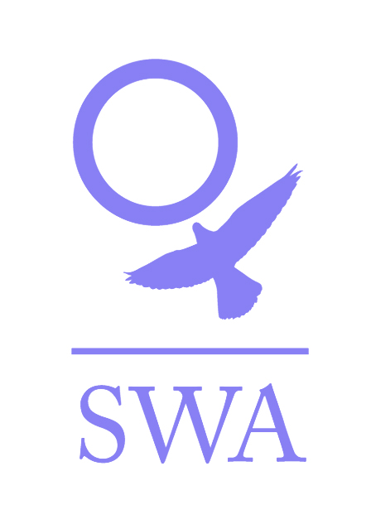

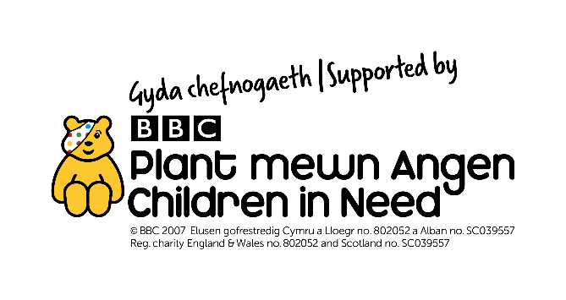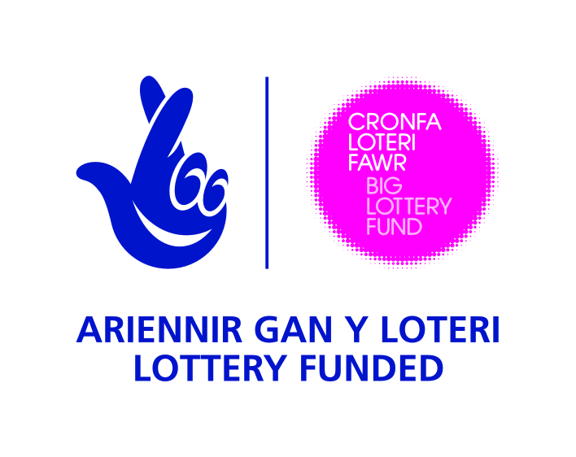

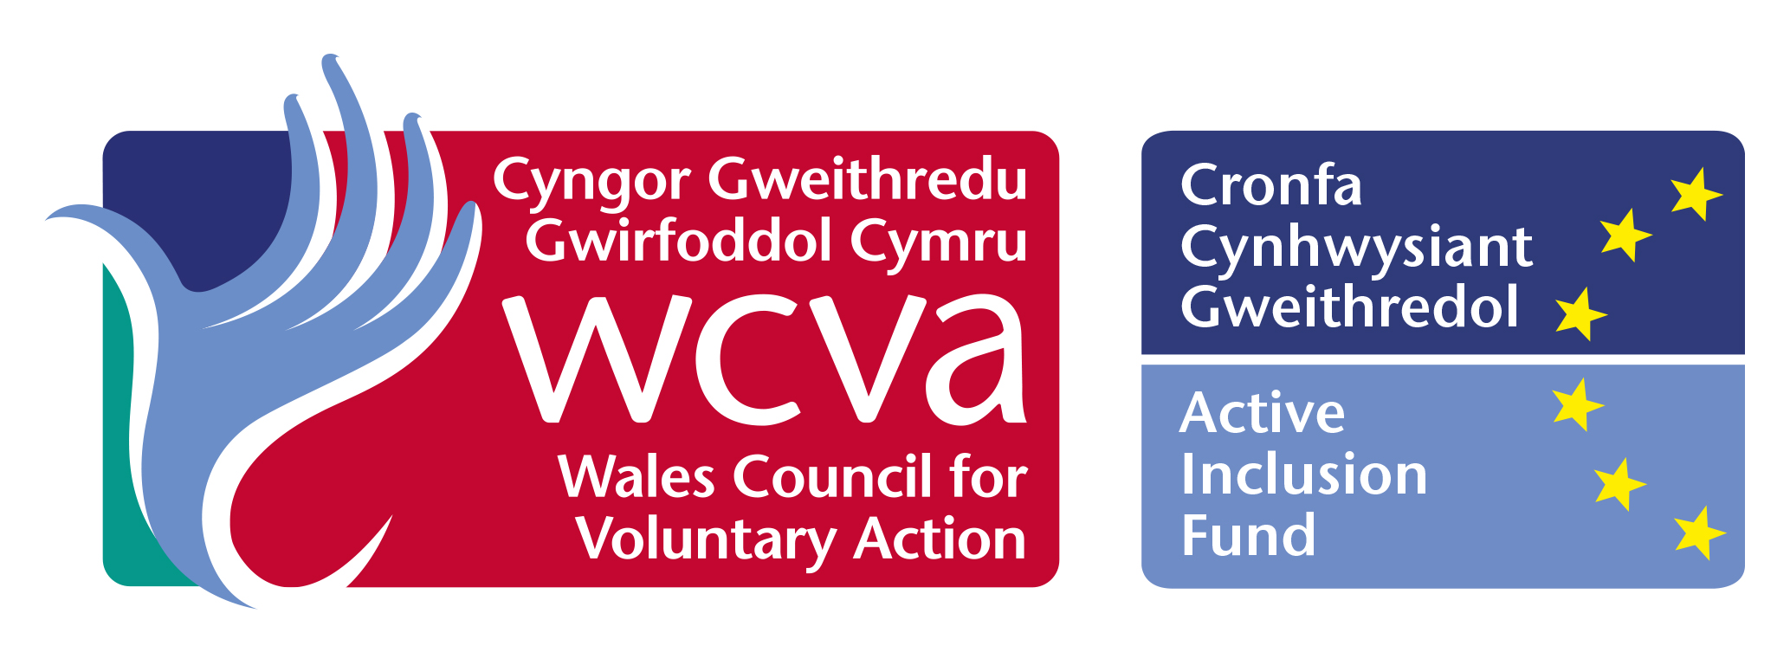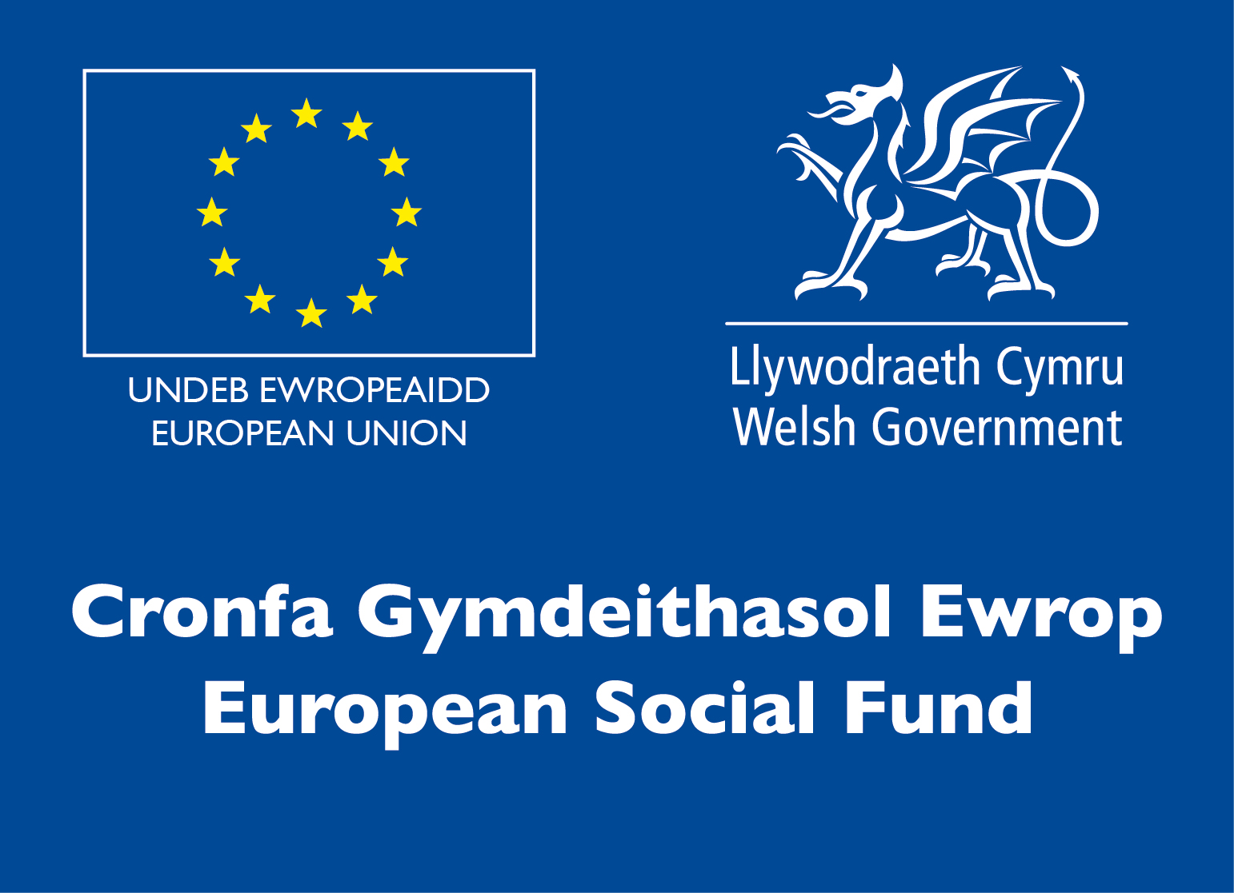
Dear Applicant,

Thank you for your interest in employment with Swansea Women’s Aid. You will find enclosed:

- Job Description and Person Specification
- Application form
- SWA mission statement and banner aims
- SWA philosophy
- Information sheet
- Project information
- Equal Opportunities Monitoring Form

Please ensure that you follow the guidelines when completing the application form. We operate an equal opportunities recruitment policy and use a pointing system for short-listing. If the application form is not completed as directed, this could mean that you will lose out on points.

Completed application forms can either be returned by post to Swansea Women’s Aid, 28 Bond St, Swansea, SA1 3TU or by email to swa@swanseawa.org.uk.

Additional information regarding Swansea Women’s Aid is available on www.swanseawomensaid.org. and you may find it useful to refer to this site when making your application.

The closing date for applications is 9am on Thursday, 1 March. Please note that any applications received after this will not be considered. Interviews will take place on Monday, 12 March 2018.

Should you require any further information regarding this post, please ring 01792 644683 and ask to speak to the CHYPS Team Leader, Lisa Conte

We wish you every success in your application.

Yours sincerely,

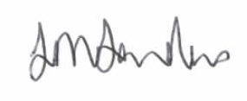
Lynne Sanders
Chief Executive

SWANSEA WOMEN’S AID

JOB DESCRIPTION

Job title: Changing Attitudes Together Project Worker

Reports To: Outreach Services Team Leader

Direct Reports : none

Main Purpose of the Role
- To provide1 to 1 sessions and group work to 13-18 year old young people who are using violence within their close relationships, aiming to increase their self-accountability, manage conflict safely in relationships and safety plan for themselves if necessary.

- Using the self-help principle, alleviate the long term effects of DA, increase children and young people’s safety and enable self - confidence and emotional wellbeing.

- Assist and facilitate service users to make informed decisions and positive changes to their lives.

Specific Responsibilities:
Supporting young people
- Work with young people aged 13 – 18 years who are using violence in their close relationships, holding 1 to 1 sessions and group sessions as appropriate using the principle of self-help to promote and encouraging independence and empowerment
- Develop support plans in line with needs assessments for approval by Team Leader, action the approved plans and review accordingly.
- Carry out risk assessment and review on a regular basis,
- Organise and coordinate age-appropriate activities.
- Establish an up to date database of information and resources for young people.
- Develop support literature for the project(e.g. a young person’s welcome/information pack, parental information sheets)
- Encourage service user participation (for example, in the development of consultation processes) through the attendance of quarterly workshops and completion of evaluation paperwork.
- Work with the SWA Your Opinion Matters Worker to gain access to skills/knowledge enhancing training for the service users.
- Comply with all child and adult protection/procedures in SWA and report to Outreach Services Team Leader any concerns /issues in this area.
- Adhere to SWA health and safety policy and report any risks/concerns to the Team Leaders, taking immediate steps where necessary to protect health and well-being of service users/team members.

Publicity
- Liaising and networking with agencies and communities to publicise the project and secure appropriate services for service users
- Publicise the project through the development and circulation of publicity materials and attendance at relevant fora, meetings and events.

Monitoring and evaluation
- Monitor the project in line with Children in Need requirements, ensuring that all documentation, reports etc are submitted by the required deadlines.
- Manage the project budget in liaison with the SWA Finance Manager and Team Leader.

Volunteers
- Direct and assist volunteers to enable them to support activities with young people.

General
- Establish and maintain accurate up to date records of all support sessions, telephone conversations, attendance and appointments etc including the progress being made on behalf of the women and children
- Act as an advocate on behalf of service users, encouraging and supporting self-advocacy as appropriate.
- Demonstrate and promote the organisation’s ethos of informed choice, and its vision and values.
- Represent the organisation at external meetings, public events, conferences and similar ensuring that Swansea Women’s Aid reputation is protected and enhanced.
- Keep up to date with changes in legislation that will affect women and children who are or have experienced domestic abuse.
- To actively work in partnership with other agencies and organisations to achieve better outcomes for women and children affected by Domestic Abuse.
- Participate in team meetings, supervision and appropriate training
- Proactively implement SWA policies for anti-discriminatory practice and equality of opportunity, ensuring that services are available for and meet the needs of all e.g. minority and disabled women etc.
- Work in accordance with SWA Policies and Procedures and standards and the overall aims and objectives of SWA.
- Any other reasonable duties as required by the Outreach Services Team Leader.
- The post holder is required to work evenings and weekends on a regular basis and to participate in the organisational 24 hour on-call rota.

PERSON SPECIFICATION

Essential Characteristics

Skills and abilities
- Clear and concise communication skills, both written and verbal.
- Strong administrative skills, e.g. filing systems, record keeping, databases, petty cash systems etc.
- Ability to liaise, network and advocate.
- Good I.T skills – ability to use basic programmes.
- Good organisational skills with the ability to manage time effectively.
- Ability to undertake risk assessment with regards to yourself, co-workers and service users.

Experience
- Experience of support planning and review and managing a caseload
- Experience of working with children and young people with differing social and emotional needs.
- Experience of managing challenging behaviour and conflict.
- Experience of group work

Knowledge
- NVQ Level 3 in childcare or equivalent or a commitment to work towards achieving one.
- Knowledge and understanding of child protection procedure
- An understanding of the causes and the long term effects of domestic abuse on women and children
- An awareness and understanding of the differing experiences of different cultural and social backgrounds
- A clear understanding of boundaries within support work.
- An understanding of the issues around service user participation and how to engage them in productive and meaningful dialogue.

Personal attributes and other requirements
- A good team player able to work as part of a team and on own initiative.
- A commitment to Swansea Women’s Aid way of working.
- An awareness and commitment to the principle of empowerment and self-help.
- Willing to work evenings and weekends as required and to participate in the organisation’s 24 hour on-call rotas.

Desirable

- A full valid driving license.
- Ability to speak welsh or other language.
- Good understanding, experience or qualification in the following:-.
- Mental Health
- Drug/Alcohol
- Counselling
- Child development

PRIVATE AND CONFIDENTIAL

SWANSEA WOMEN’S AID
APPLICATION FORM

POST: CHANGING ATTITUDES TOGETHER WORKER

PERSONAL DETAILS

Name: ………………………………………….

Address:…………………………………………………………………………..

…………………………………………………………………………………...

…………………………………………………Post code: ……………………

Tel No: (Day)…………………………… (Eve)……………………………..

E Mail address:………………………………………………..
Please note if your daytime tel. no is your present employment: If we need to ring you in relation to this post, we will not disclose this.

Please give the name of two referees, one of whom must be your recent/previous employer. Please note that references will only be taken up when an offer of employment is made

Name………………………………….. Name………………………………………

Position……………………………….. Position……………………………………

Address……………………………….. Address……………………………………

………………………………………... …………………………………………….

……………………………………….. …………………………………………….

Postcode……………………………… Postcode…………………………………..
Email: Email:

Successful appointment is subject to satisfactory references and an enhanced Disclosure and Barring Service Check

Under the Equality Act 2010 pursuant to Schedule 9, Part 1, this is a women only post
Before you complete the application form please take note of the guidelines
Question 1 IF EASIER FOR QUESTIONS 1 AND 2, PLEASE ATTACH
YOUR CV INSTEAD OF FILLING IN THE FORM

EMPLOYMENT HISTORY
As an organisation, SWA attaches equal value to experience gained through both paid and voluntary employment.
DATES  FROM TO | EMPLOYER’S NAME & ADDRESS | POSITION HELD & DUTIES | SALARY & REASON FOR LEAVING

Question 2
SWA is interested in any formal or informal qualifications that you may have, particularly those relevant to this post. Please also include details of any relevant training undertaken.

QUALIFICATIONS
DATES  FROM TO | SCHOOL,COLLEGE, UNIVERSITY ETC | QUALIFICATION &/OR COURSE NAME
TRAINING COURSES/SEMINARS ATTENDED
DATE ATTENDED | ORGANISING BODY | DETAILS OF COURSE/SEMINAR including any certification awarded
Question 3
With reference to the Person Specification for the post, please explain and provide examples of how you meet each of the 8 essential criterion listed below. Please attach a continuation sheet.
- Ability to liaise, network and advocate.
- Ability to undertake risk assessment with regards to yourself, co-workers and service users.
- Experience of support planning and review and managing a caseload.
- Experience of working with children and young people with differing social and emotional needs.
- Experience of managing challenging behaviour and conflict.
- An understanding/experience of the causes and the long term effects of domestic abuse on women and children
- A clear understanding of boundaries within support work.
- An awareness and commitment to the principle of empowerment and self-help.

Please then complete the table below, ticking Yes or No to indicate whether or not you meet the criterion

Essential criteria | Yes | No
- Clear and concise communication skills, both written and verbal
- Strong administrative skills, e.g. filing systems, record keeping, databases, petty cash systems etc
- Ability to liaise, network and advocate.
- Good I.T skills – ability to use basic programmes
- Ability to work as part of a team and on own initiative
- Good organisational skills with the ability to manage time effectively.
- Experience of group work
- NVQ Level 3 in childcare or equivalent or a commitment to work towards achieving one.
- Knowledge and understanding of child protection procedure
- An awareness and an understanding of the differing experiences of different cultural and social backgrounds
- An understanding of the issues around service user participation and how to engage them in productive and meaningful dialogue.
- A good team player able to work as part of a team and on own initiative.
- A commitment to Swansea Women’s Aid way of working.
- Willing to work evenings and weekends as required and to participate in the organisation’s 24 hour on-call rotas.
Desirable criteria | Yes | No
- A full valid driving licence
- Ability to speak welsh or other language
- Good understanding, experience or qualification in the following.
- Mental Health
- Drug/Alcohol
- Counselling
- Child Development

Question 4
Please give brief details of your personal interests and hobbies, particularly where they illustrate the use of skills and personal qualities relevant to the post.

Question 5
COMPUTER LITERACY
Do you have any experience of using work processors/computers?

YES / NO

If YES, please give details of software packages used:

Question 6
Please tell us of any dates when you would not be available for interview: ……………………

DECLARATION
I certify that all the information provided in this application form is true, accurate and complete to the best of my knowledge and that I have the right to work in the United Kingdom. I understand that should this not be the case, then it may put any offer of employment made by SWA in jeopardy, or result in dismissal.

SIGNED: …………………………… DATED: ……………………

ON COMPLETION, PLEASE RETURN THIS APPLICATION FORM, MARKED PRIVATE AND CONFIDENTIAL, TO:

The Chief Executive,
Swansea Women’s Aid.
28 Bond St,
Swansea
SA1 3TU

OR

By email to swa@swanseawa.org.uk

Applications must reach us by the closing date for this post: 9am on Thursday, 1 March 2018.

Data Protection
This application form will be kept securely, in a paper-based filing system and used only for short-listing purposes by the recruitment panel. Application forms are kept for a limited period of time only.

Please indicate below where you saw the job advertisement for this post:

………………………………………………………………………………………………..
E.g. Job Centre, Charity Job Finder, Recruit 3, SWA website etc

Filling in the form guidelines

If you have a communication difficulty such as dyslexia, please make us aware of this.

Pointing system

In order to reach the shortlist, an applicant must meet ALL of the essential criteria in the Person Specification. Each essential criterion carries points of 0 to 3. Each desirable criterion carries points of 0 to 1. If an applicant points zero on any of the essential criteria, they will not be considered for the shortlist, even if the applicant pointed highly elsewhere. Applicants who are short-listed generally point between 2 & 3 on each essential criterion. Applicants do not need to score on the desirable criteria to be short- listed.

To score between 2 & 3, an applicant must outline their experience / ability and then demonstrate.

For example, a question in the application form asks about applicant’s organisational skills. An applicant may state that in all their jobs they have been required to have good organisational skills (Outlining experience). Demonstrate this by telling us how you developed them, for example, ‘through work where I was required to…’ or, ‘through training / voluntary work / education, it was essential to…’

It is essential when answering Question 3 that you ensure you address each of the stipulated essential criterion. The easiest way to ensure this is to use the headings and numberings as follows:

For example

- 1.Experience of working with women (and children) with differing social and emotional needs.
Answer

- An awareness and an understanding of the differing experiences of different cultural and social backgrounds.
Answer

- An understanding/experience of the causes and the long term effects of domestic abuse.
Answer

This advice may seem a bit basic but it is surprising how often applicants can focus on certain essential criteria and fall short on others. We want all applicants to have the best possible opportunity to highlight the required experience and skills to work effectively within this post.

SWANSEA WOMEN’S AID

Vision
A world where women and children are free from abuse

Mission statement

Supporting and empowering women and children to live free from domestic violence and abuse in all its forms.

Values

- Excellence – in all we do and how we do it

- Equality –non-discriminatory and non-judgemental

- Diversity – everyone welcomed and valued

- Women and children at the heart of all we do – being supported, informing and directing services

- Innovation – in service delivery and planning

- Integrity - honesty, reliability, trustworthiness

- Empowerment – encouraging women and children to reach their full potential

- Confidential – respecting privacy and lawful

- Collaborative – working with others to change things for the better

SWANSEA WOMEN’S AID - PHILOSOPHY

Women only
Swansea Women’s Aid is part of the wider Women’s Aid movement, run by women for women. We believe that in order to develop confidence and self-esteem, women need ‘space’ to identify their strength and weaknesses away from male influence. Sexism serves not only to systematically undermine and abuse women but also to divide women and alienate them from each other. We feel that the ‘space’ that Women’s Aid provides for women allows them to define themselves according to their own needs and not according to the attitudes of society.

Admissions
Refuge and Safe House space is there for all women who are experiencing domestic violence and are afraid to live in their own homes. We do not discriminate against any woman on grounds of race, religion, sexual orientation or disability. If our Refuge or Safe Houses in Swansea are full, we will contact other groups throughout Wales until Refuge space is found.

Self Help
It is essential to our work to provide a place of safety where women can determine their own future. Women staying in the Refuge are responsible for the day to day running of the house. We believe that it is crucial that women are given the space to rebuild their confidence so that they can resume responsibility for their lives in an atmosphere of mutual respect and co-operation. Women’s Aid supports women in this development at whatever stage individual women are at any time.

SWANSEA WOMEN’S AID
INFORMATION SHEET

JOB TITLE: CHANGING ATTITUDES TOGETHER WORKER

HOURS OF WORK: 35 PER WEEK
Hours are agreed and need to be worked flexibly. The demands of the service will require you to work evenings and weekends. Any overtime will be compensated for by time in lieu.

SALARY: £20020 per annum

CONTRACT LENGTH: This is a 4 month post funded by Children in Need. An application for continuation funding has been made.

HOLIDAY ENTITLEMENT: 25 days per year plus bank holidays.

PROBATIONARY PERIOD: One month

PENSION: Swansea Women’s Aid contributes 6% of the basic annual salary into a pension of your choice.

OTHER:

All workers are required to undergo an enhanced Disclosure and Barring Service check.

The post holder will participate in the 24-hour on call rota if the post continues beyond 4 months. This will include out-of-hours admissions into the refuge and safe houses and call outs to deal with housing management issues.

Swansea Women’s Aid is a women-only organisation with both paid and unpaid workers and is affiliated to Welsh Women’s Aid.

Swansea Women’s Aid is an equal opportunities employer and welcomes applications from all sectors of the community.

CHAT

Changing attitudes together


Young people can be referred by agencies such as schools, social services, police, health services, youth services etc. A referral form will need to be completed by the referring agency.

Parental consent is required, however we will accept referrals for young people 16+ who are living independently.

To request a referral form or further information please contact:

CHAT Worker
Tel: 01792 644683
Or E-mail: xxxx@swanseawa.org.uk

The changing attitudes together (CHAT) project offers support to young people aged 11-18 who have been affected by domestic abuse and who have used or are using violence/abusive or controlling behaviours in their relationships with parents/carers or towards their girl/boyfriends. We adopt a young person led approach and work hard to support young people to understand their experiences of domestic abuse and how this may have affected them and their relationships.
The CHAT project works to promote healthy relationships and prevent domestic abuse in future relationships by supporting young people to acknowledge and change their behavior.

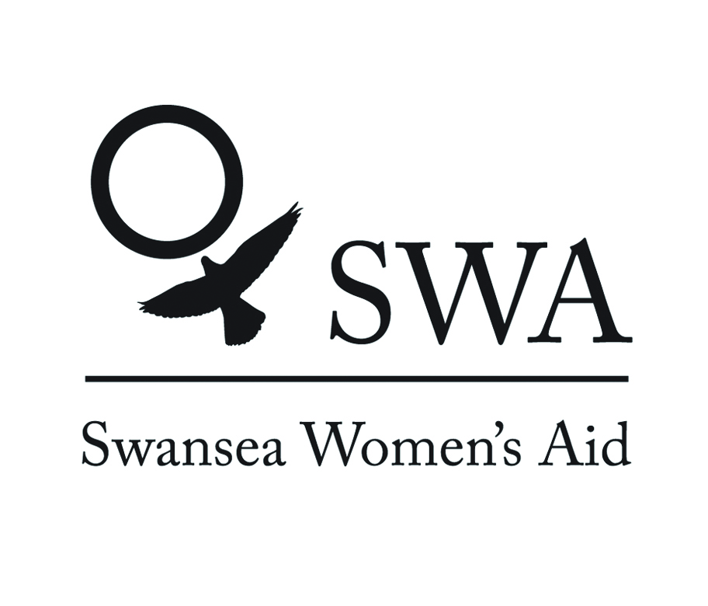
SWA
Equal Opportunities Monitoring Form

SWA recognises and actively promotes the benefits of a diverse workforce and is committed to treating all employees with dignity and respect.

In accordance with our equal opportunities policy, SWA will provide equality of opportunity to all employees and job applicants and will not discriminate either directly or indirectly on the grounds of race, sex, gender identity, marital status, disability, sexual orientation, pregnancy or maternity, religion/belief or age.

We have only asked for your name so that monitoring can take place at short listing and appointment stages. The monitoring form does not form part of your application and will therefore be detached from it on receipt, stored separately and will not be available to the selection panel. You can send it separately if you wish.
Personal Details:
Please complete all sections

Age | 16-24 | 25-29 |  |  | 30-34 |  | 35-39 |  |  | 40-44
 | 45-49 | 50-54 |  |  | 55-59 |  | 60-64 |  |  | 65+
Gender | Male |  |  |  |  | Female
Gender Identity (options) | If you identify as transsexual, transgender (in that you have effected a permanent change of gender identity) or as intersex which group do you identify with?
Gender Identity (options) | Transsexual |  |  | Transgender |  |  |  |  | Intersex
Married/Civil partnership | Yes |  | No |  |  |  |  | Prefer not to say

Pregnancy and Maternity
I am pregnant/adopting a child Yes No Prefer not to say

Sexual Orientation: Please tick against one of the following

Bisexual |  | Gay Man
Gay Woman / Lesbian |  | Heterosexual / Straight
Other |  | Prefer not to say

Religion or belief: Please tick against one of the following

No religion |  | Buddhist |  | Christian
Hindu |  | Jewish |  | Muslim
Sikh |  | Prefer not to say
Other |  | Please state:

Ethnic origin: Please tick against one of the following

Asian/  Asian British; | Bangladeshi
Asian/  Asian British; | Chinese
Asian/  Asian British; | Indian
Asian/  Asian British; | Pakistani
Asian/  Asian British; | Other Asian
Black/African/Caribbean/  Black British; | African
Black/African/Caribbean/  Black British; | Caribbean
Black/African/Caribbean/  Black British; | Other Black
Mixed/  Multiple Ethnic Groups; | White & Asian
Mixed/  Multiple Ethnic Groups; | White & Black African
Mixed/  Multiple Ethnic Groups; | White & Black Caribbean
Mixed/  Multiple Ethnic Groups; | Other Mixed
Other Ethnic Group; | Arab
Other Ethnic Group; | Any Other Ethnic Group
White; | English/Welsh/Scottish/Northern Irish/British
White; | Gypsy or Irish Traveller
White; | Irish
White; | Other White
Prefer not to say

Disability: Please tick against one of the following

Disability definition under the Equality Act 2010
In the Act, a person has a disability if:
- they have a physical or mental impairment
- the impairment has a substantial and long-term adverse effect on their ability to perform normal day-to-day activities
- For the purposes of the Act, these words have the following meanings:
- 'substantial' means more than minor or trivial
- 'long-term' means that the effect of the impairment has lasted or is likely to last for at least twelve months (there are special rules covering recurring or fluctuating conditions)
- 'normal day-to-day activities' include everyday things like eating, washing, walking and going shopping
People who have had a disability in the past that meets this definition are also protected by the Act.

Progressive conditions considered to be a disability
There are additional provisions relating to people with progressive conditions. People with HIV, cancer or multiple sclerosis are protected by the Act from the point of diagnosis. People with some visual impairment are automatically deemed to be disabled.

Conditions that are specifically excluded
Some conditions are specifically excluded from being covered by the disability definition, such as a tendency to set fires or addictions to non–prescribed substances.

Do you consider yourself to have a disability according to the terms above? Yes/No/Prefer not to say
If you have answered yes, please indicate the type of impairment which applies to you. If your experience more than one type of impairment, please tick all the types that apply. If your disability does not fit any of these types, please circle Other and specify.
Physical/mobility impairment, such as a difficulty using your arms or mobility issues which require you to use a wheelchair or crutches
Visual impairment, such as being blind or having a serious visual impairment
Hearing impairment, such as being deaf or having a serious hearing impairment
Mental health condition, such as depression or schizophrenia
Learning disability/difficulty, such as Down’s syndrome or dyslexia or a cognitive impairment such as autistic spectrum disorder
Long-standing illness or health condition, such as cancer, HIV, diabetes, chronic heart disease or epilepsy
Other (Please specify below)
Other (prefer not to say)

Yes No Prefer not to say

This information is provided for monitoring purposes only – if you need reasonable adjustments you should arrange these separately.

Thank you for taking the time to complete the information requested on this form, and thereby enabling us to monitor the effectiveness of our equal opportunities policy.

Signature: Date:

